|  |  |  |  |  |
| --- | --- | --- | --- | --- |
|  |  | | |  |
|  |  | | |  |
|  | Function Group Spec  Profile Interface Client - FnG  <<Logical>> (Allocated) | | |  |
|  |  |
|  |  |
|  |  | | |  |
| Document Type | **Function Specification** | | |  |
| Template Version | **6.0** | | |  |
| SysML Report Template Version | **O Beta (11/6/2019)** | | |  |
| Document ID | VDOC089825 | | |  |
| Document Location | [VSEM Link](https://www.vsemweb.ford.com/tc/launchapp?-attach=true&-s=226TCSession&-o=FYV5z4zQx3NrTDAAAAAAAAAAAAA&servername=Production_Server) | | |  |
| Document Owner | **Justin Bauer, Walter Stephens** | | |  |
| Document Revision | **1.4** | | |  |
| Document Status | **RELEASED** | | |  |
| Date Issued | **2021-03-10** | | |  |
| Date Revised | **2021-11-03** | | |  |
| Document Classification | GIS1 Item Number: | **27.60/35** | |  |
| GIS2 Classification: | **Confidential** | |
|  | | | | |
|  | | | | |
| Document Approval | | | | |
| Name | Role | | Email Confirmation | Date |
|  |  | |  |  |
|  |  | |  |  |

Auto-Generated by MagicDraw

Printed Copies are Uncontrolled

# Disclaimer

**This document contains Ford Motor Company Confidential information. Disclosure of the information contained in any portion of this document is not permitted without the expressed, written consent of a duly authorized representative of Ford Motor Company, Dearborn, Michigan, U.S.A.**

**Copyright, Ó 2016 Ford Motor Company**

This document contains information developed and accumulated by and for FORD MOTOR COMPANY. As such, it is a proprietary document, which, if disseminated to unauthorized persons, would provide others with restricted information, data, or procedures not otherwise available, exposing the FORD MOTOR COMPANY to potential harm.

Employees and suppliers having custody of this specification or authorized to use it must be cognizant of its proprietary nature and ensure that the information herein is not made available to unauthorized persons.

FORD MOTOR COMPANY reserves the right to protect this work as an unpublished copyrighted work in the event of an inadvertent or deliberate unauthorized publication. FORD MOTOR COMPANY also reserves its rights under copyright laws to protect this work as a published work.

This document or portions thereof shall not be distributed outside FORD MOTOR COMPANY without prior written consent. Refer all questions concerning disclosure to the author(s) or to any duly authorized representative of Ford Motor Company.

# Contents

1.1.1 Decomposition of 4

Disclaimer 16

Contents 17

2 Introduction 19

2.1 Document Purpose 19

2.2 Document Scope 19

2.3 Document Audience 19

2.3.1 Stakeholder List 19

2.4 Document Organization 19

2.4.1 Document Context 19

2.4.2 Document Structure 19

2.5 Document Conventions 20

2.5.1 Requirements Templates 20

3 Function Group Description 21

4 Functional Architecture 22

4.1 Description 22

4.2 Function List 22

4.3 Signal List 22

5 Function Specifications 23

5.1  23

5.1.1 Function Overview 23

5.1.2 Function Scope 25

5.1.3 Function Interfaces 26

5.1.4 Function Modeling 28

5.1.5 Function Requirements 28

6 Open Concerns 32

7 Revision History 33

8 Appendix 34

8.1 Data Dictionary 34

8.1.1 Logical Signals 34

8.1.2 Logical Parameters 34

8.1.3 Encoding Types 34

8.2 Glossary 34

8.2.1 Definitions 34

8.2.2 Abbreviations 35

**List of Figures**

Figure 1 Activity diagram “” depicting black box behavior collaboration 22

Figure 2: Activity Diagram of “” calling “” 26

Figure 3: 28

**List of Tables**

Table 1: - Decomposition Table 5

Table 2: Functions described in this specification 19

Table 3: List of Logical Functions 22

Table 4: Ford internal Documents 25

Table 5: Ford internal Documents *(not specified in model)* 25

Table 6: External documents and publications 25

Table 7: External documents and publications *(not specified in model)* 25

Table 8: Open Concerns *(Not supported by MagicDraw report generation.)* 32

Table 9: Definitions used in this document 35

Table 10: Abbreviations used in this document 35

# Introduction

## Document Purpose

The Function (Group) Specification (FS) specifies an individual function / a group of functions.

To get more information about the concept of feature, function and component level abstraction refer to the [Ford RE Wiki](http://wiki.ford.com/display/RequirementsEngineering/Requirements+Engineering+for+SW+Enabled+Features).

## Document Scope

The following set of functions from the [Global Feature & Function List](https://www.vsemweb.ford.com:443/tc/launchapp?-attach=true&-s=226TCSession&-o=ZmZNi0JHx3NrTDAAAAAAAAAAAAA) is described in this specification.

|  |  |  |  |
| --- | --- | --- | --- |
| **Function ID** | **Function Name** | **Function Description** | **ASIL** |
|  | 1062874125.jpg Delete Passenger Profile Data <<Subsystem Function>> | This function deletes all passenger profile header information from the Profile Interface Client (Name, Avatar, etc.) and sends a request to the Profile Management Server to delete the profile from storage. |  |
|  | 1062874125.jpg Send Passenger Recall Request <<Subsystem Function>> | Profile Interface Client requests the Profile Management Server to initial a passenger profile recall. |  |
|  | -744324041.jpg Update and Store Wizard Settings <<Subsystem Function>> |  |  |
|  | 1062874125.jpg Display Passenger Setup Wizard Flow <<Subsystem Function>> | HMI function that navigates the user through a Passenger Profile Creation Setup Wizard. |  |
|  | 1062874125.jpg Display Passenger Profile Creation Prompt <<Subsystem Function>> | HMI function to display a Passenger Profile Creation Prompt when there are no Passenger Profiles created. |  |
|  | -744324041.jpg Request New Profile Creation <<Subsystem Function>> |  |  |
|  | 1062874125.jpg Send Passenger Store Command <<Subsystem Function>> | Function that requests the Passenger Classic Memory system to store the current seat position to the requested PersIndex. |  |
|  | -744324041.jpg Read PPP Configuration Status <<Subsystem Function>> | Upon receiving configuration request, this function updates the configuration value to turn the feature ON or OFF based on the data from the received request. |  |
|  | 1062874125.jpg Display Passenger Profile Creation Status <<Subsystem Function>> | HMI function that displays the status of a new Passenger Profile Creation. |  |
|  | 1062874125.jpg Display Passenger Edit Profile Menu <<Subsystem Function>> | HMI function to display some Passenger Profile settings that can be edited by the user. |  |
|  | 1062874125.jpg Display Option to Create Passenger Profile <<Subsystem Function>> | HMI function that displays when a Passenger Profile can be created. |  |
|  | 1062874125.jpg Display active front passenger profile <<Subsystem Function>> | HMI function that displays to the user the active Front Passenger Profile. |  |
|  | 1062874125.jpg Display Passenger Profiles Menu <<Subsystem Function>> | HMI function that displays all available Passenger Profiles. |  |
| Fn012420/A | -744324041.jpg Lockout Profile for Download <<Subsystem Function>> | This function is allocated to the Profile Interface Client and provides an HMI graphic that locks out the HMI screen so that the customer cannot make any changes while the PPP feature is applying settings. |  |
| Fn012441/A | -744324041.jpg Display Login Method <<Subsystem Function>> | This is an HMI function that is displayed to collect user credentials from the user. The credentials are used to authenticate a user in order to link their profile to their FordPass account and import their profile settings. |  |
| Fn012452/A | -744324041.jpg Primary Authentication <<Subsystem Function>> | This is an HMI function that allows the user to setup their primary authentication method for their profile. |  |
| Fn012454/A | -744324041.jpg Unlink Ford Account <<Subsystem Function>> | HMI function that provides the capability for the user to link their FP account to any pre-existing vehicle profiles. |  |

**Table 2: Functions described in this specification**

## Document Audience

The FS is authored by the owners of the individual functions. All Stakeholders, i.e., all people who have a valid interest in the functions and their behavior should read and, if possible, review the FS. It needs to be guaranteed, that all stakeholders have access to the currently valid version of the FS.

**#Hint:** The FS template has the IP Classification “Proprietary” by default. IP Classification “Confidential” might be required in some cases, e.g. by Ford Functional Safety.

### Stakeholder List

For the latest list of the feature stakeholder and their roles & responsibilities refer to [PPP Stakeholder List](https://www.vsemweb.ford.com/tc/launchapp?-attach=true&-s=226TCSession&-o=S5U9Hrgbx3NrTDAAAAAAAAAAAAA&servername=Production_Server)

**#Hint:** Refer to [Ford RE Wiki – Stakeholder List](http://wiki.ford.com/display/RequirementsEngineering/Stakeholder+Analysis) on how to create a stakeholder list. The stakeholder list should be stored in VSEM in the pseudo folder “General Data Artifacts” of the corresponding function.

## Document Organization

### Document Context

Refer to the [Specification Structure page](http://wiki.ford.com/display/RequirementsEngineering/Specification+templates) in the [Ford RE Wiki](http://wiki.ford.com/display/RequirementsEngineering/Requirements+Engineering+for+SW+Enabled+Features) to understand how the FS relates to other Ford Requirements Documents and Specifications.

### Document Structure

The structure of this document is explained below:

**Section 1** – Introduction how to use this document including responsibilities and requisite documents. Explains the terminology. Gives a clarification of the definitions, concepts and abbreviations used in the document.

**Section 2** – Function Group Description. Gives an overview and the purpose of the function group.

**Section 3** – Functional Architecture: Specifies the overall functional architecture of the function group

**Section 4** – Function Specifications: Specifies the logical functions of the function group in detail

**Section 5** – List of Open Concerns

**Section 6** Revision history including a list of new or modified requirements. The requirements in this document are tagged, and this section contains different types of tables listing all, new, or changed requirements by their title and page no.

**Section 7** – Appendix: Presenting additional data mainly in a tabular form, e.g., a data dictionary

**#Hint:** All sections are mandatory, unless explicitly marked by the tag “#Classification” as “optional” or as applicable e.g. to certain domains like “Functional Safety”.

## Document Conventions

### Requirements Templates

Each requirement, use case or scenario in this specification shall follow the corresponding template given in the document template *Specification_Macros.dotm* at [RE Wiki - Specification Templates](http://wiki.ford.com/display/RequirementsEngineering/Specification+templates?src=contextnavpagetreemode).

#### Identification of Requirements

#### Requirements Attributes

The templates provided by *Specification_Macros.dotm* define a list of attributes for each requirement. This helps to classify the requirement. The attributes are explained at [RE Wiki - Requirements Attributes](http://wiki.ford.com/display/RequirementsEngineering/Requirements+Attributes?src=contextnavpagetreemode).

# Function Group Description

**#Classification:** Function Group only (remove section, if only a single Function is specified in this document)

**#Hint**: Provide an overview / a description of the Function Group

This Function Group consists of all functions allocated to -1143646936.jpg **Profile Interface Client - FnG** <<Logical>> including all functions in their corresponding call trees.

Description of Profile Interface Client - FnG:

The Profile Interface Client is the subsystem that interfaces with the customer inside of the host vehicle. Any functionality that requires a display or an interaction with the customer isl be provided through this subsystem. The Profile Interface Client is also in charge of alerting the customer if there are any errors within the system.

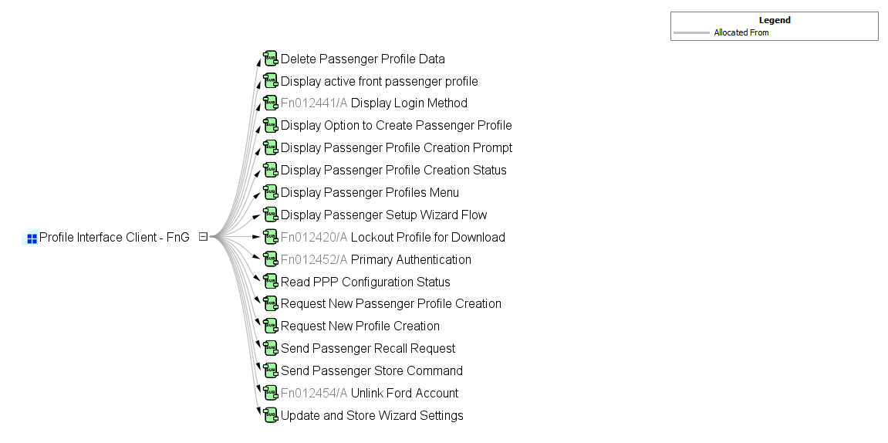

# Functional Architecture

**#Classification:** Function Group only (remove section, if only a single Function is specified in this document)

**#Hint:** The Functional Architecture shall reflect the result of the functional decomposition for a given feature or parts of it.

Refer to the [*RE Wiki – Functional Decomposition*](http://wiki.ford.com/display/RequirementsEngineering/Functional+Analysis+and+Architecture) for some guidance on how to decompose a feature into functions, i.e., how to find the right functional partitioning for the function level. The functions shown here are those, which are specified in section 5 “Function Specifications”.

## Description

**#Hint:** Provide some informal description of the characteristics of the chosen architecture. Also give some graphical representation of the Functional Architecture. Either SysML Internal Block diagrams or [Data Flow Diagrams](http://wiki.ford.com/display/RequirementsEngineering/Data+Flow+Diagram?src=contextnavpagetreemode) could be used to depict such a Functional Architecture.

**#Link:** [*SysML – Internal Block Diagrams*](https://pd3.spt.ford.com/sites/SystemsEngineering/SEC/sysml-teamsite/SysML%20Wiki/Internal%20Block%20Diagram%20Basics.aspx) or [*RE Wiki - Data Flow Diagrams*](http://wiki.ford.com/display/RequirementsEngineering/Data+Flow+Diagram?src=contextnavpagetreemodehttp://wiki.ford.com/display/RequirementsEngineering/Data+Flow+Diagram?src=contextnavpagetreemode)

## Function List

|  |  |  |  |
| --- | --- | --- | --- |
| **Function ID** | **Function Name** | **Function Description** | **ASIL** |
|  | 1062874125.jpg Delete Passenger Profile Data <<Subsystem Function>> | This function deletes all passenger profile header information from the Profile Interface Client (Name, Avatar, etc.) and sends a request to the Profile Management Server to delete the profile from storage. |  |
|  | 1062874125.jpg Send Passenger Recall Request <<Subsystem Function>> | Profile Interface Client requests the Profile Management Server to initial a passenger profile recall. |  |
|  | -744324041.jpg Update and Store Wizard Settings <<Subsystem Function>> |  |  |
|  | 1062874125.jpg Display Passenger Setup Wizard Flow <<Subsystem Function>> | HMI function that navigates the user through a Passenger Profile Creation Setup Wizard. |  |
|  | 1062874125.jpg Display Passenger Profile Creation Prompt <<Subsystem Function>> | HMI function to display a Passenger Profile Creation Prompt when there are no Passenger Profiles created. |  |
|  | -744324041.jpg Request New Profile Creation <<Subsystem Function>> |  |  |
|  | 1062874125.jpg Send Passenger Store Command <<Subsystem Function>> | Function that requests the Passenger Classic Memory system to store the current seat position to the requested PersIndex. |  |
|  | -744324041.jpg Read PPP Configuration Status <<Subsystem Function>> | Upon receiving configuration request, this function updates the configuration value to turn the feature ON or OFF based on the data from the received request. |  |
|  | 1062874125.jpg Display Passenger Profile Creation Status <<Subsystem Function>> | HMI function that displays the status of a new Passenger Profile Creation. |  |
|  | 1062874125.jpg Display Passenger Edit Profile Menu <<Subsystem Function>> | HMI function to display some Passenger Profile settings that can be edited by the user. |  |
|  | 1062874125.jpg Display Option to Create Passenger Profile <<Subsystem Function>> | HMI function that displays when a Passenger Profile can be created. |  |
|  | 1062874125.jpg Display active front passenger profile <<Subsystem Function>> | HMI function that displays to the user the active Front Passenger Profile. |  |
|  | 1062874125.jpg Display Passenger Profiles Menu <<Subsystem Function>> | HMI function that displays all available Passenger Profiles. |  |
| Fn012420/A | -744324041.jpg Lockout Profile for Download <<Subsystem Function>> | This function is allocated to the Profile Interface Client and provides an HMI graphic that locks out the HMI screen so that the customer cannot make any changes while the PPP feature is applying settings. |  |
| Fn012441/A | -744324041.jpg Display Login Method <<Subsystem Function>> | This is an HMI function that is displayed to collect user credentials from the user. The credentials are used to authenticate a user in order to link their profile to their FordPass account and import their profile settings. |  |
| Fn012452/A | -744324041.jpg Primary Authentication <<Subsystem Function>> | This is an HMI function that allows the user to setup their primary authentication method for their profile. |  |
| Fn012454/A | -744324041.jpg Unlink Ford Account <<Subsystem Function>> | HMI function that provides the capability for the user to link their FP account to any pre-existing vehicle profiles. |  |

Table 3: List of Logical Functions

## Signal List

Refer to the Data Dictionary - Logical Signals.

# Function Specifications

## 1062874125.jpg Delete Passenger Profile Data

### Function Overview

#### Description

**#Hint:** Some descriptive text to explain the purpose and functionality of the function.

Function is allocated to:

* 1716959969.jpg Front Passenger Profiles <<Feature>>
* 1069245878.jpg Profile Interface Client - FnG <<Logical>>

This function deletes all passenger profile header information from the Profile Interface Client (Name, Avatar, etc.) and sends a request to the Profile Management Server to delete the profile from storage.

#### Variants

**#Classification**: Mandatory (State “Not applicable”, if not used)

**#Hint:** If different variants of the same function are specified in this section, list those variants in the table below.

Variants on Function level could be driven technology or feature content. Example: There could be a “Low Content” and a “High Content” variant of some exterior lighting function. The Low Content variant applies for Conventional Headlight technology, the High Content variant applies for LED and Xenon technology. In this case we call the different technologies the Variant Options (for the time being you could think of them as Logical Parameters) which the Variant depends on. The optional column “Variant condition” allows to express the dependency of a Variant based on Variant Options/Logical Parameters.

If requirements/signals are not applicable for all variants/variant options, those requirements should state explicitly, which function variant/variant option they apply to.

**#Link:** [RE Wiki – Variant Management](http://wiki.ford.com/display/RequirementsEngineering/Variant+Management).

*Not supported by MagicDraw report generation.*

#### Input Requirements

**#Classification**: Mandatory (State “Not applicable”, if not used)

**#Hint:** List any input requirements here (legal, Trustmark), which need to be taken into account, beyond what is specified in the corresponding Feature Documents.

*Not supported by MagicDraw report generation.*

#### Assumptions

**#Classification**: Mandatory (State “Not applicable”, if not used)

**#Hint:** A list of known assumptions concerning the effects of the function’s behavior on other functions or elements (i.e., dependencies) as well as assumptions on the behavior expected by the function (e.g. known limitations). During the course of the development most of those assumptions are typically either converted into actual requirements or discarded at some point – such that this chapter remains mostly empty.

No assumptions specified for this function.

#### References

##### Ford Documents

List here all Ford internal documents, which are directly related to the feature.

| **Reference** | **Title** | **Doc. ID** | **Revision** |
| --- | --- | --- | --- |
|  |  |  |  |

Table 5: Ford internal Documents *(not specified in model)*

##### External Documents and Publications

The list of external documents could include books, reports and online sources.

**#Hint:** You may refer to [IEEE Citation Reference](http://www.ieee.org/documents/ieeecitationref.pdf) on how to format a reference.

| **Reference** | **Document / Publication** |
| --- | --- |
|  |  |

Table 7: External documents and publications *(not specified in model)*

#### Glossary

See Appendix for Definitions and Abbreviations.

### Function Scope

The 1062874125.jpg **– “Delete Passenger Profile Data”** function is called by the following functions:

* -556409490.jpg – “Delete Passenger Profile”

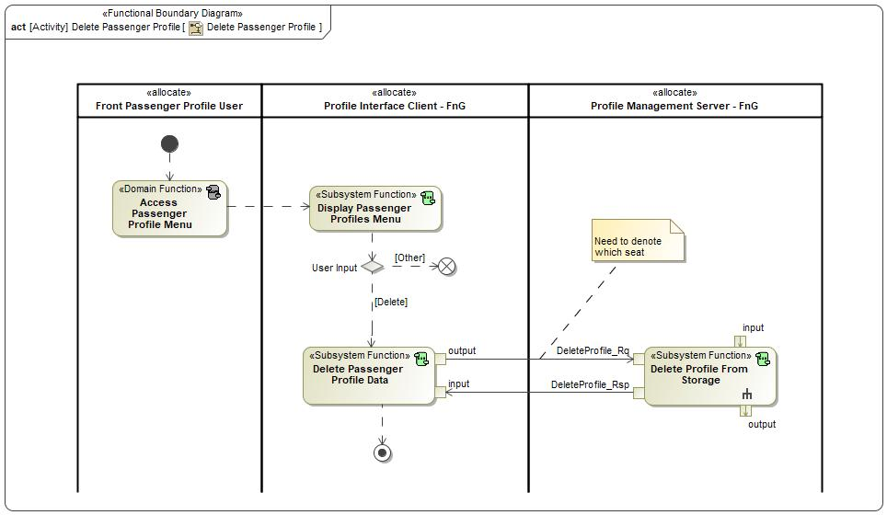

Figure 2: Activity Diagram of -556409490.jpg “Delete Passenger Profile” calling 1062874125.jpg “Delete Passenger Profile Data”

### Function Interfaces

**#Link:** [RE Wiki – Adding a Logical Signal or Parameter](http://wiki.ford.com/display/RequirementsEngineering/Adding+a+Logical+Signal+or+Parameter)

#### Logical Inputs

|  |  |
| --- | --- |
| **Signal Name** | **Description** |
| input  Type:  686277085.jpg DeleteProfile_Rsp | Signal Description:  Profile Management Server response to the DeleteProfile_Rq. Indicates Success or Failure.  Received from:   * -744324041.jpg Delete Profile From Storage |

#### Logical Outputs

|  |  |
| --- | --- |
| **Signal Name** | **Description** |
| output  Type:  686277085.jpg DeleteProfile_Rq | Signal Description:  A command to the Profile Management Server to delete a specific profile.  Sent to:   * -744324041.jpg Delete Profile From Storage |

#### Logical Parameters

**#Hint**: Put requirements for parameters here, which are implemented as configuration parameters using Method 2 or 3 or as parameters for calibration.

*Not supported by MagicDraw report generation.*

### Function Modeling

**#Classification:** Mandatory

**#Hint:** Typical modeling artifacts in this section are State Machines, Activity Diagrams / Flow Charts, Decision Tables, and possibly Sequence Diagrams, which can all be used as techniques to analyze the function requirements.

**#Links:** Analyze / Model Requirements: [RE Wiki – Analyze / Model Requirements](http://wiki.ford.com/pages/viewpage.action?pageId=110594919&src=contextnavpagetreemode)

#### Use Cases

**#Classification:** Infotainment Only (remove section, if not used)

**#Hint:** Some Domains (e.g. Infotainment) use not only Customer Use Cases (in the Feature Doc), but refine Use Case descriptions down to function level. In general, the RE approach encourages the use of Use Cases on Feature Level but not on Function Level. Activity Diagrams are a more suitable way to express the same on Function Level.

**#Links:** Infotainment – “Harmony Systems Engineering” Approach

*Not supported by MagicDraw report generation.*

#### State Charts / Activity Diagrams / Sequence Diagrams / Decision Tables

**#Classification:** Mandatory

**#Hint:** It is highly recommended to use at least one of the following modeling techniques for modeling and analyzing the Function behavior and derived requirements (refer to sample diagrams below):

State Machines, Activity Diagrams / Flow Charts, or Decision Tables

Optionally, Sequence Diagrams might help to analyze the interaction between Functions.

**#Links:** Analyze / Model Requirements: [RE Wiki – Analyze / Model Requirements](http://wiki.ford.com/pages/viewpage.action?pageId=110594919&src=contextnavpagetreemode)

State Charts [RE Wiki – State Charts](http://wiki.ford.com/display/RequirementsEngineering/State+Charts?src=contextnavpagetreemode)

Activity Diagrams: [RE Wiki – Activity Diagram](http://wiki.ford.com/display/RequirementsEngineering/Activity+Diagram?src=contextnavpagetreemode), [SysML User Group – Activity Diagram Basics](https://pd3.spt.ford.com/sites/SystemsEngineering/SEC/sysml-teamsite/SysML%20Wiki/Activity%20Diagram%20Basics.aspx)

Sequence Diagrams: [RE Wiki – Sequence Chart](http://wiki.ford.com/display/RequirementsEngineering/Sequence+Chart?src=contextnavpagetreemode), [SysML User Group – Sequence Diagram Basics](https://pd3.spt.ford.com/sites/SystemsEngineering/SEC/sysml-teamsite/SysML%20Wiki/Sequence%20Diagram%20Basics.aspx)

No diagrams internal to function specified.

### Function Requirements

#Link: [*RE Wiki – How to write good requirements*](http://wiki.ford.com/display/RequirementsEngineering/How+to+write+better+requirements?src=contextnavpagetreemode)

#### Functional Requirements

***#Hint:*** *Please also consider specific situations like Initialization (Startup) and Deinitialization (Shutdown) apart from Normal Operation and Error Handling. E.g. a* state chart or activity diagram might help for better understanding.

##### Normal Operation

REQ-462305/A Request to delete Passenger Profile data from storage

When a Passenger Profile is requested to be deleted, the Profile Interface Client shall send DeleteProfile_Rq with the below fields to the Profile Management Server to delete all associated Passenger Profile data from storage.

* Profile_Type = Passenger
* PersIndex = PROFILE_1 – PROFILE_10

|  |  |  |  |  |  |  |  |
| --- | --- | --- | --- | --- | --- | --- | --- |
| Requirement ID: | | | | | | | |
| **Rationale** |  | | | | | | |
| **Acceptance Criteria** |  | | | | | | |
| **Notes** |  | | | | | | |
| **Source** |  | | | | | **Owner** |  |
| **Source Req.** |  | | | | | **V&V Method** |  |
| **Type** |  | | | **Priority** |  | **Status** |  |
| [Req. Template](http://wiki.ford.com/display/RequirementsEngineering/Requirements+Attributes) Version | | 6.0 | End of Requirement | | | | |

REQ-462304/A Delete Passenger Profile Data

When a Passenger Profile is requested to be deleted and the Profile Interface Client receives confirmation that the Passenger Profile data has been deleted from the Profile Management Server, the Profile Interface Client shall delete any profile data and remove the deleted profile from the Passenger Profile menu.

|  |  |  |  |  |  |  |  |
| --- | --- | --- | --- | --- | --- | --- | --- |
| Requirement ID: | | | | | | | |
| **Rationale** |  | | | | | | |
| **Acceptance Criteria** |  | | | | | | |
| **Notes** |  | | | | | | |
| **Source** |  | | | | | **Owner** |  |
| **Source Req.** |  | | | | | **V&V Method** |  |
| **Type** |  | | | **Priority** |  | **Status** |  |
| [Req. Template](http://wiki.ford.com/display/RequirementsEngineering/Requirements+Attributes) Version | | 6.0 | End of Requirement | | | | |

##### Error Handling

***#Hint:*** *FMEA counter measures could be considered as requirements in this chapter*

No Error Handling Requirements specified.

#### Non-Functional Requirements

***#Hint:*** *Non-functional requirements specify some performance criteria in addition to the functional behavior given defined by the functional requirements. Timing (if not already included in the functional requirements), security details (e.g. how secure does an algorithm have to be) or reliability (e.g. mean time between failure) could be specified in this section.*

No Non-Functional Requirements specified.

#### Functional Safety Requirements

**#Classification**: Functional Safety only – If not used, remove content and state “Not Applicable”

***#Hint:*** *Add Functional Safety Requirements (FSRs) derived for this function.*

**#Link:** [Functional Safety Sharepoint](https://pd3.spt.ford.com/sites/GlobalFunctionalSafety/Pages/default.aspx) – Functional Safety Concept

[RE Wiki - Requirements Attributes](http://wiki.ford.com/display/RequirementsEngineering/Requirements+Attributes)

No Functional Safety Requirements specified.

##### ASIL Decomposition of Functional Safety Requirements

**#Classification**: Functional Safety only – If not used, remove content and state “Not Applicable”

***#Hint:*** *Sometimes an ASIL decomposition of Functional Safety Requirements is required. The decomposed FSRs should be listed beneath each ASIL Decomposition table below and referenced inside the table by ID and Title*

**#Link:** [Functional Safety Sharepoint](https://pd3.spt.ford.com/sites/GlobalFunctionalSafety/Pages/default.aspx) – Functional Safety Concept

No Functional Safety Requirements with ASIL Decompositions specified.

#### Other Requirements

##### Design Requirements

***#Hint:*** *Requirements of a Logical Function should be typically agnostic of their SW/HW implementation*. If for specific reasons the function owner needs to define explicitly design constraints, it can be done in this chapter.

No Design Requirements specified.

## 1062874125.jpg Display active front passenger profile

### Function Overview

#### Description

Function is allocated to:

* 1716959969.jpg Front Passenger Profiles <<Feature>>
* 1069245878.jpg Profile Interface Client - FnG <<Logical>>

HMI function that displays to the user the active Front Passenger Profile.

#### Variants

*Not supported by MagicDraw report generation.*

#### Input Requirements

*Not supported by MagicDraw report generation.*

#### Assumptions

No assumptions specified for this function.

#### References

##### Ford Documents

List here all Ford internal documents, which are directly related to the feature.

| **Reference** | **Title** | **Doc. ID** | **Revision** |
| --- | --- | --- | --- |
|  |  |  |  |

Table 5: Ford internal Documents *(not specified in model)*

##### External Documents and Publications

The list of external documents could include books, reports and online sources.

| **Reference** | **Document / Publication** |
| --- | --- |
|  |  |

Table 7: External documents and publications *(not specified in model)*

#### Glossary

See Appendix for Definitions and Abbreviations.

### Function Scope

The 1062874125.jpg **– “Display active front passenger profile”** function is called by the following functions:

* -556409490.jpg – “Recall Passenger Profile”
* -556409490.jpg – “Reload Passenger Seat Position”

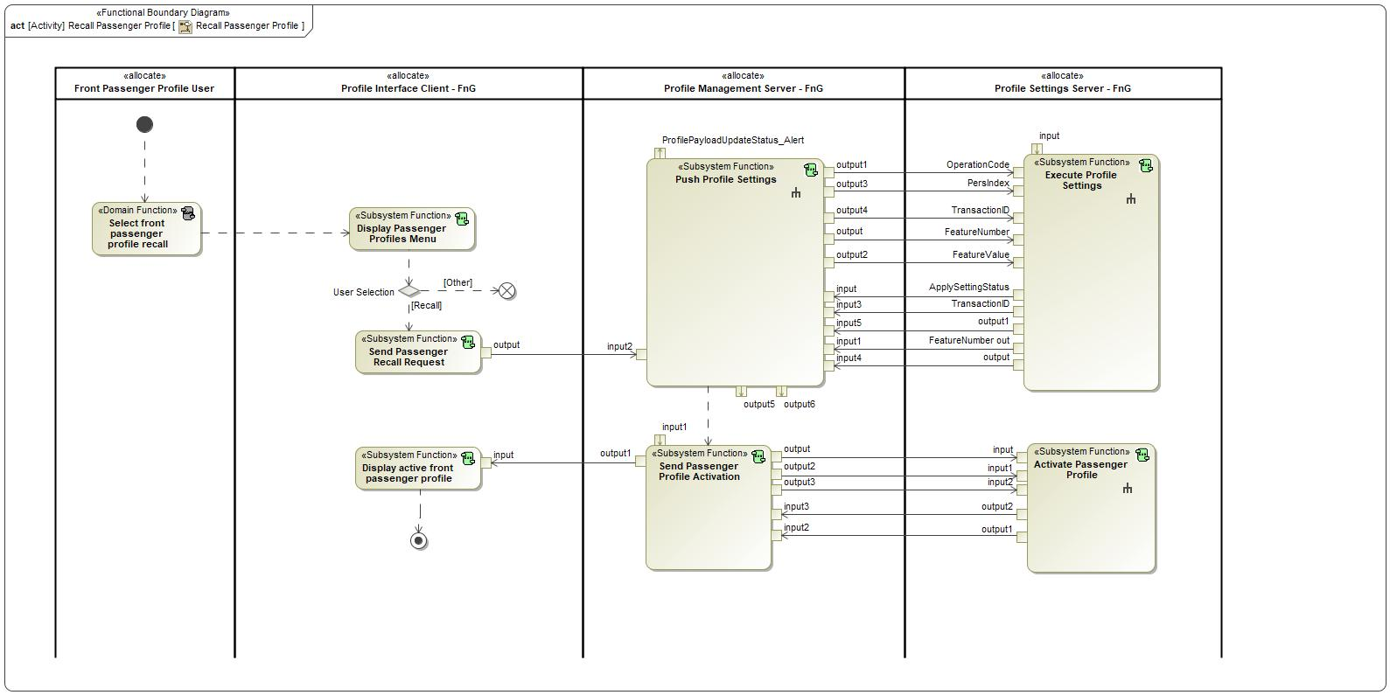

Figure 2: Activity Diagram of -556409490.jpg “Recall Passenger Profile” calling 1062874125.jpg “Display active front passenger profile”

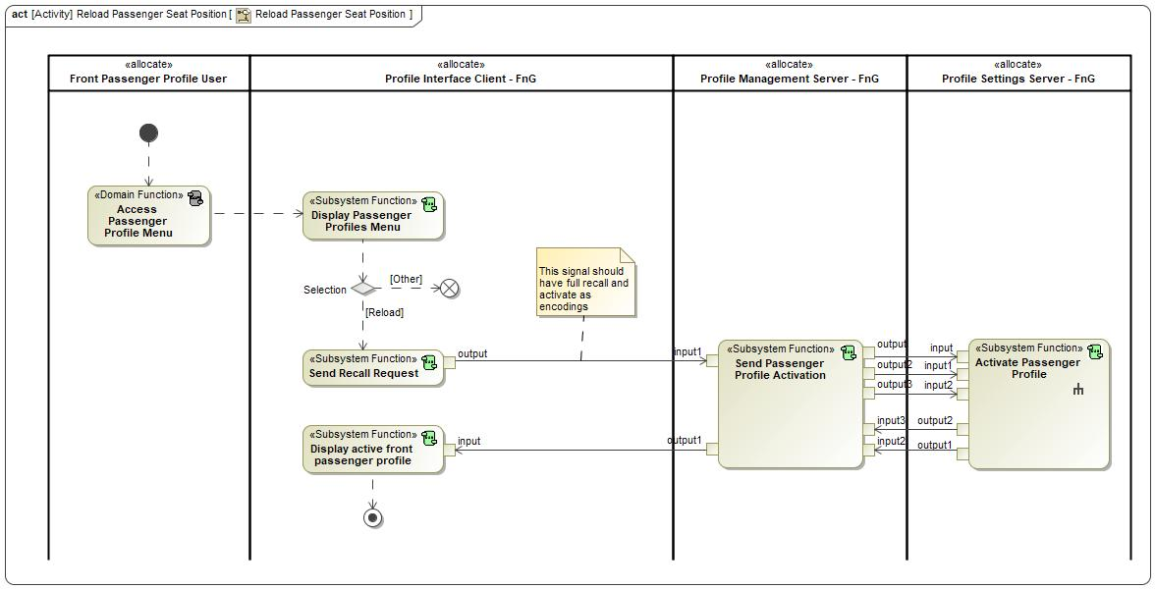

Figure 2: Activity Diagram of -556409490.jpg “Reload Passenger Seat Position” calling 1062874125.jpg “Display active front passenger profile”

### Function Interfaces

#### Logical Inputs

|  |  |
| --- | --- |
| **Signal Name** | **Description** |
| input  Type:  686277085.jpg PsngrProfileActive_St | Signal Description:  Status indicating the active passenger profile  Received from:   * 2133516449.jpg Send Passenger Profile Activation |

#### Logical Outputs

No Logical Outputs specified.

#### Logical Parameters

*Not supported by MagicDraw report generation.*

### Function Modeling

#### Use Cases

*Not supported by MagicDraw report generation.*

#### State Charts / Activity Diagrams / Sequence Diagrams / Decision Tables

No diagrams internal to function specified.

### Function Requirements

#### Functional Requirements

##### Normal Operation

REQ-462307/A Displaying the active front Passenger Profile after recall

After a front Passenger Profile Recall event has successfully completed (PsngrProfileActive_St = recalled profile), the Profile Interface Client shall immediately display an indicator of the active front Passenger Profile.

|  |  |  |  |  |  |  |  |
| --- | --- | --- | --- | --- | --- | --- | --- |
| Requirement ID: | | | | | | | |
| **Rationale** |  | | | | | | |
| **Acceptance Criteria** |  | | | | | | |
| **Notes** |  | | | | | | |
| **Source** |  | | | | | **Owner** |  |
| **Source Req.** |  | | | | | **V&V Method** |  |
| **Type** |  | | | **Priority** |  | **Status** |  |
| [Req. Template](http://wiki.ford.com/display/RequirementsEngineering/Requirements+Attributes) Version | | 6.0 | End of Requirement | | | | |

REQ-462306/A Displaying the active front Passenger Profile

The Profile Interface Client shall have a method of identifying which Passenger Profile is the currently active profile.

|  |  |  |  |  |  |  |  |
| --- | --- | --- | --- | --- | --- | --- | --- |
| Requirement ID: | | | | | | | |
| **Rationale** |  | | | | | | |
| **Acceptance Criteria** |  | | | | | | |
| **Notes** |  | | | | | | |
| **Source** |  | | | | | **Owner** |  |
| **Source Req.** |  | | | | | **V&V Method** |  |
| **Type** |  | | | **Priority** |  | **Status** |  |
| [Req. Template](http://wiki.ford.com/display/RequirementsEngineering/Requirements+Attributes) Version | | 6.0 | End of Requirement | | | | |

##### Error Handling

REQ-462308/A Failure in recalling a new Passenger Profile

If there is a failure when recalling a new front Passenger Profile, the Profile Interface Client shall display the last active Passenger Profile as the currently active Passenger Profile.

|  |  |  |  |  |  |  |  |
| --- | --- | --- | --- | --- | --- | --- | --- |
| Requirement ID: | | | | | | | |
| **Rationale** |  | | | | | | |
| **Acceptance Criteria** |  | | | | | | |
| **Notes** |  | | | | | | |
| **Source** |  | | | | | **Owner** |  |
| **Source Req.** |  | | | | | **V&V Method** |  |
| **Type** |  | | | **Priority** |  | **Status** |  |
| [Req. Template](http://wiki.ford.com/display/RequirementsEngineering/Requirements+Attributes) Version | | 6.0 | End of Requirement | | | | |

#### Non-Functional Requirements

No Non-Functional Requirements specified.

#### Functional Safety Requirements

No Functional Safety Requirements specified.

##### ASIL Decomposition of Functional Safety Requirements

No Functional Safety Requirements with ASIL Decompositions specified.

#### Other Requirements

##### Design Requirements

No Design Requirements specified.

## -744324041.jpg Display Login Method

### Function Overview

#### Description

Function is allocated to:

* -1546686851.jpg Display Login Method - APIM <<Logical>>
* 1069245878.jpg Profile Interface Client - FnG <<Logical>>

This is an HMI function that is displayed to collect user credentials from the user. The credentials are used to authenticate a user in order to link their profile to their FordPass account and import their profile settings.

#### Variants

*Not supported by MagicDraw report generation.*

#### Input Requirements

*Not supported by MagicDraw report generation.*

#### Assumptions

No assumptions specified for this function.

#### References

##### Ford Documents

List here all Ford internal documents, which are directly related to the feature.

| **Reference** | **Title** | **Doc. ID** | **Revision** |
| --- | --- | --- | --- |
|  |  |  |  |

Table 5: Ford internal Documents *(not specified in model)*

##### External Documents and Publications

The list of external documents could include books, reports and online sources.

| **Reference** | **Document / Publication** |
| --- | --- |
|  |  |

Table 7: External documents and publications *(not specified in model)*

#### Glossary

See Appendix for Definitions and Abbreviations.

### Function Scope

The -744324041.jpg **– “Display Login Method”** function is called by the following functions:

* -556409490.jpg – “1 Link New Vehicle Profile w/ FP Account”
* -556409490.jpg – “2 Link Pre-existing Vehicle Profile w/ FP account”

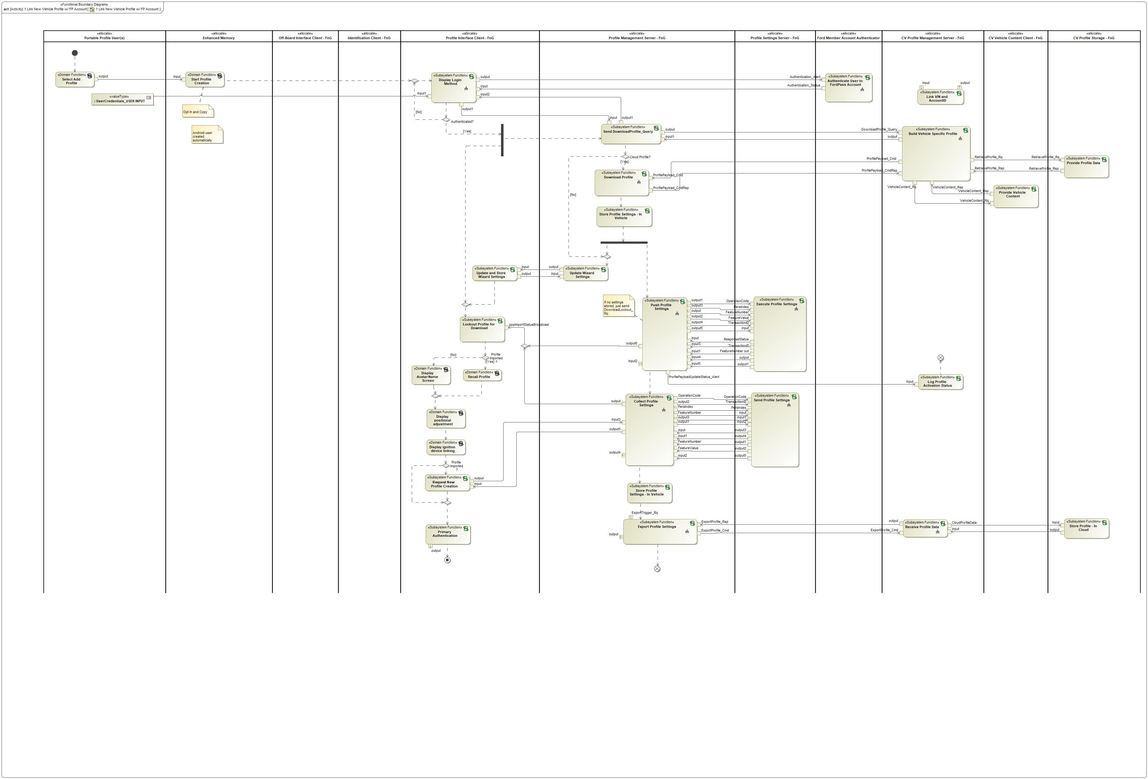

Figure 2: Activity Diagram of -556409490.jpg “1 Link New Vehicle Profile w/ FP Account” calling -744324041.jpg “Display Login Method”

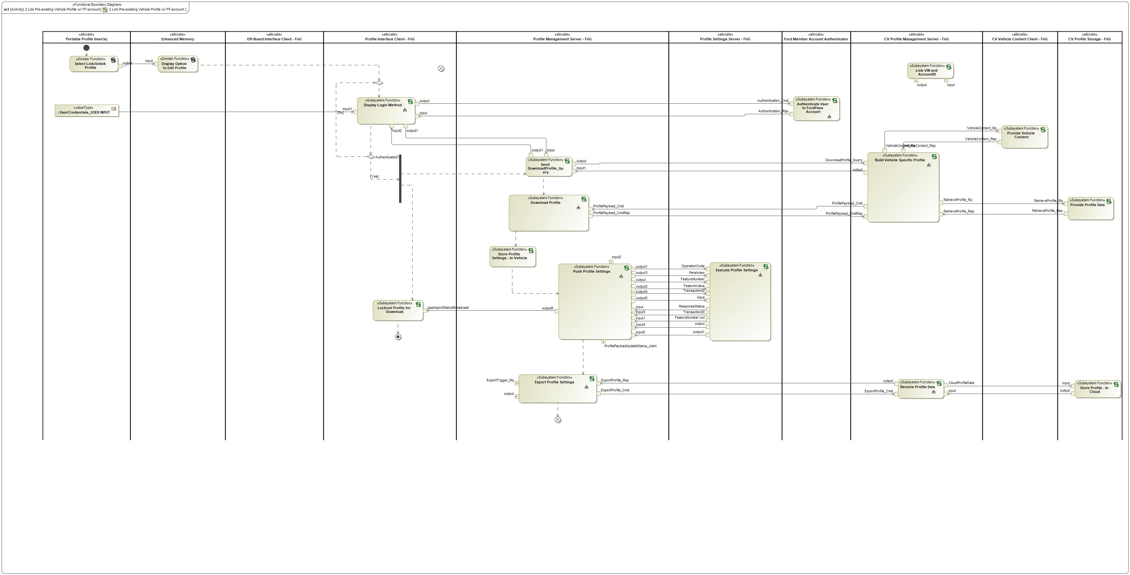

Figure 2: Activity Diagram of -556409490.jpg “2 Link Pre-existing Vehicle Profile w/ FP account” calling -744324041.jpg “Display Login Method”

### Function Interfaces

#### Logical Inputs

|  |  |
| --- | --- |
| **Signal Name** | **Description** |
| input1  Type:  686277085.jpg UserCredentials_USER INPUT | Signal Description:  USER INPUT - provides Profile Interface Client with account credentials. |
| input2  Type:  686277085.jpg pppProfileID_Res | Signal Description:  Response to pppProfileID_Rq indicating if the Profile ID is new or already in use.  Received from:   * -744324041.jpg Send DownloadProfile_Query |
| input  Type:  686277085.jpg Authentication_Status | Signal Description:  A success or failure response for the Authentication_Cmd. The response tells the vehicle if the provided credentials are authenticated or not and provides a ProfileID.  Received from:   * -744324041.jpg Authenticate User to FordPass Account |

#### Logical Outputs

|  |  |
| --- | --- |
| **Signal Name** | **Description** |
| output  Type:  686277085.jpg Authentication_Alert | Signal Description:  Profile credentials sent to the cloud to be authenticated.  Sent to:   * -744324041.jpg Authenticate User to FordPass Account |
| output1  Type:  686277085.jpg pppProfileID_Rq | Signal Description:  Profile ID passed to the Profile Management Server after Ford Account Login.  Sent to:   * -744324041.jpg Send DownloadProfile_Query |

#### Logical Parameters

*Not supported by MagicDraw report generation.*

### Function Modeling

#### Use Cases

*Not supported by MagicDraw report generation.*

#### State Charts / Activity Diagrams / Sequence Diagrams / Decision Tables

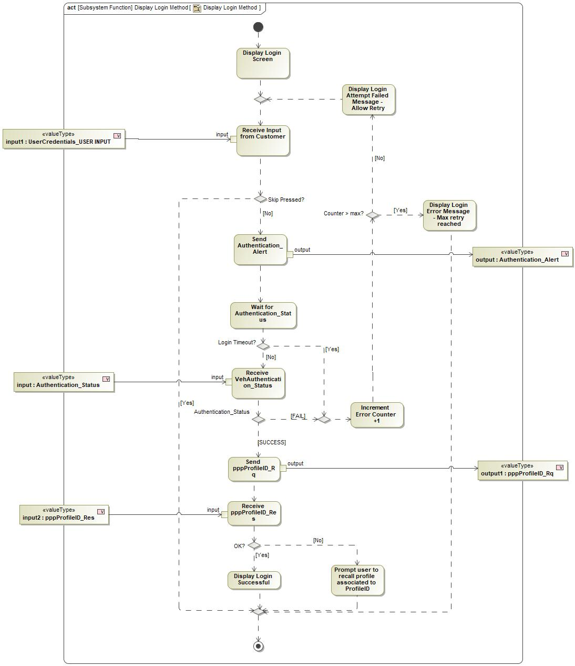

Figure 3: Display Login Method

### Function Requirements

#### Functional Requirements

##### Normal Operation

REQ-405766/A Login Method Options

The Profile Interface Client shall provide a method for the user to login (credentials, QR code, etc) to their Ford Account in the vehicle during the following scenarios:

- Profile Creation

- Editing and associated Account

|  |  |  |  |  |  |  |  |
| --- | --- | --- | --- | --- | --- | --- | --- |
| Requirement ID: REQ-405766/A | | | | | | | |
| **Rationale** |  | | | | | | |
| **Acceptance Criteria** |  | | | | | | |
| **Notes** |  | | | | | | |
| **Source** |  | | | | | **Owner** |  |
| **Source Req.** |  | | | | | **V&V Method** |  |
| **Type** |  | | | **Priority** |  | **Status** |  |
| [Req. Template](http://wiki.ford.com/display/RequirementsEngineering/Requirements+Attributes) Version | | 6.0 | End of Requirement | | | | |

REQ-405769/A Maximum login attempts reached

When the maximum (max = 5) attempts to login to a Ford Account has been reached, the Profile Interface Client shall display an error message and exit the Ford Account Login Screen.

|  |  |  |  |  |  |  |  |
| --- | --- | --- | --- | --- | --- | --- | --- |
| Requirement ID: REQ-405769/A | | | | | | | |
| **Rationale** |  | | | | | | |
| **Acceptance Criteria** |  | | | | | | |
| **Notes** |  | | | | | | |
| **Source** |  | | | | | **Owner** |  |
| **Source Req.** |  | | | | | **V&V Method** |  |
| **Type** |  | | | **Priority** |  | **Status** |  |
| [Req. Template](http://wiki.ford.com/display/RequirementsEngineering/Requirements+Attributes) Version | | 6.0 | End of Requirement | | | | |

REQ-460539/A Receiving Authentication_Status = SUCCESS

When the Profile Interface Client receives Authentication_Status = SUCCESS and a valid ProfileID after sending Authentication_Alert during Ford Account Login, the Profile Interface Client shall send pppProfileID_Rq to the Profile Management Server containing the ProfileID received from the Authentication_Status.

|  |  |  |  |  |  |  |  |
| --- | --- | --- | --- | --- | --- | --- | --- |
| Requirement ID: REQ-460539/A | | | | | | | |
| **Rationale** |  | | | | | | |
| **Acceptance Criteria** |  | | | | | | |
| **Notes** |  | | | | | | |
| **Source** |  | | | | | **Owner** |  |
| **Source Req.** |  | | | | | **V&V Method** |  |
| **Type** |  | | | **Priority** |  | **Status** |  |
| [Req. Template](http://wiki.ford.com/display/RequirementsEngineering/Requirements+Attributes) Version | | 6.0 | End of Requirement | | | | |

REQ-460543/A pppProfileID_Res = Already In Use

If the Profile Interface Client receives pppProfileID_Res = Already In Use after sending pppProfileID_Rq, then the Profile Interface Client shall notify the user and prompt user to recall profile associated with the ProfileID.

|  |  |  |  |  |  |  |  |
| --- | --- | --- | --- | --- | --- | --- | --- |
| Requirement ID: REQ-460543/A | | | | | | | |
| **Rationale** |  | | | | | | |
| **Acceptance Criteria** |  | | | | | | |
| **Notes** |  | | | | | | |
| **Source** |  | | | | | **Owner** |  |
| **Source Req.** |  | | | | | **V&V Method** |  |
| **Type** |  | | | **Priority** |  | **Status** |  |
| [Req. Template](http://wiki.ford.com/display/RequirementsEngineering/Requirements+Attributes) Version | | 6.0 | End of Requirement | | | | |

##### Error Handling

REQ-405768/A Receiving Authentication_Status = FAIL

When the Profile Interface Client receives Authentication_Status = FAILED after sending Authentication_Alert during Ford Account login, the Profile Interface Client shall display a failed login attempt message and prompt the user to retry if max retries have not been reached.

|  |  |  |  |  |  |  |  |
| --- | --- | --- | --- | --- | --- | --- | --- |
| Requirement ID: REQ-405768/A | | | | | | | |
| **Rationale** |  | | | | | | |
| **Acceptance Criteria** |  | | | | | | |
| **Notes** |  | | | | | | |
| **Source** |  | | | | | **Owner** |  |
| **Source Req.** |  | | | | | **V&V Method** |  |
| **Type** |  | | | **Priority** |  | **Status** |  |
| [Req. Template](http://wiki.ford.com/display/RequirementsEngineering/Requirements+Attributes) Version | | 6.0 | End of Requirement | | | | |

REQ-460542/A Ford Account Login Timeout

After sending Authentication_Alert, the Profile Interface Client shall wait for up to 10s for Authentication_Status response. If no response is received within that time, the Profile Interface Client shall consider the attempt a Failure and prompt the user to retry if maximum retries have not yet been reached.

|  |  |  |  |  |  |  |  |
| --- | --- | --- | --- | --- | --- | --- | --- |
| Requirement ID: REQ-460542/A | | | | | | | |
| **Rationale** |  | | | | | | |
| **Acceptance Criteria** |  | | | | | | |
| **Notes** |  | | | | | | |
| **Source** |  | | | | | **Owner** |  |
| **Source Req.** |  | | | | | **V&V Method** |  |
| **Type** |  | | | **Priority** |  | **Status** |  |
| [Req. Template](http://wiki.ford.com/display/RequirementsEngineering/Requirements+Attributes) Version | | 6.0 | End of Requirement | | | | |

#### Non-Functional Requirements

REQ-460538/A Duration to display login screen

The Profile Interface Client shall display the login screen until one of the following events occur:

- User selects "skip" option

- User enters and submits username and password

- Alternative login method (QR code) successfully used

- Login retry reaches error retry count limit

- Vehicle no longer in park

|  |  |  |  |  |  |  |  |
| --- | --- | --- | --- | --- | --- | --- | --- |
| Requirement ID: REQ-460538/A | | | | | | | |
| **Rationale** |  | | | | | | |
| **Acceptance Criteria** |  | | | | | | |
| **Notes** |  | | | | | | |
| **Source** |  | | | | | **Owner** |  |
| **Source Req.** |  | | | | | **V&V Method** |  |
| **Type** |  | | | **Priority** |  | **Status** |  |
| [Req. Template](http://wiki.ford.com/display/RequirementsEngineering/Requirements+Attributes) Version | | 6.0 | End of Requirement | | | | |

#### Functional Safety Requirements

No Functional Safety Requirements specified.

##### ASIL Decomposition of Functional Safety Requirements

No Functional Safety Requirements with ASIL Decompositions specified.

#### Other Requirements

##### Design Requirements

No Design Requirements specified.

#### Uncategorized Requirements

REQ-460540/A Provide option to skip

When the Profile Interface Client displays the Ford Account login screen, the Profile Interface Client shall provide an option for the user to skip the login.

|  |  |  |  |  |  |  |  |
| --- | --- | --- | --- | --- | --- | --- | --- |
| Requirement ID: REQ-460540/A | | | | | | | |
| **Rationale** |  | | | | | | |
| **Acceptance Criteria** |  | | | | | | |
| **Notes** |  | | | | | | |
| **Source** |  | | | | | **Owner** |  |
| **Source Req.** |  | | | | | **V&V Method** |  |
| **Type** |  | | | **Priority** |  | **Status** |  |
| [Req. Template](http://wiki.ford.com/display/RequirementsEngineering/Requirements+Attributes) Version | | 6.0 | End of Requirement | | | | |

REQ-460541/A DID to track method of login used

The Profile Interface Client shall create a DID that will track the method to login to the vehicle that is used by the user.

- one DID to track username/password entry as a login

- one DID to track QR code as a login

|  |  |  |  |  |  |  |  |
| --- | --- | --- | --- | --- | --- | --- | --- |
| Requirement ID: REQ-460541/A | | | | | | | |
| **Rationale** |  | | | | | | |
| **Acceptance Criteria** |  | | | | | | |
| **Notes** |  | | | | | | |
| **Source** |  | | | | | **Owner** |  |
| **Source Req.** |  | | | | | **V&V Method** |  |
| **Type** |  | | | **Priority** |  | **Status** |  |
| [Req. Template](http://wiki.ford.com/display/RequirementsEngineering/Requirements+Attributes) Version | | 6.0 | End of Requirement | | | | |

## 1062874125.jpg Display Option to Create Passenger Profile

### Function Overview

#### Description

Function is allocated to:

* 1716959969.jpg Front Passenger Profiles <<Feature>>
* 1069245878.jpg Profile Interface Client - FnG <<Logical>>

HMI function that displays when a Passenger Profile can be created.

#### Variants

*Not supported by MagicDraw report generation.*

#### Input Requirements

*Not supported by MagicDraw report generation.*

#### Assumptions

No assumptions specified for this function.

#### References

##### Ford Documents

List here all Ford internal documents, which are directly related to the feature.

| **Reference** | **Title** | **Doc. ID** | **Revision** |
| --- | --- | --- | --- |
|  |  |  |  |

Table 5: Ford internal Documents *(not specified in model)*

##### External Documents and Publications

The list of external documents could include books, reports and online sources.

| **Reference** | **Document / Publication** |
| --- | --- |
|  |  |

Table 7: External documents and publications *(not specified in model)*

#### Glossary

See Appendix for Definitions and Abbreviations.

### Function Scope

The 1062874125.jpg **– “Display Option to Create Passenger Profile”** function is called by the following functions:

* -556409490.jpg – “Create Passenger Profile via HMI - First Entry”

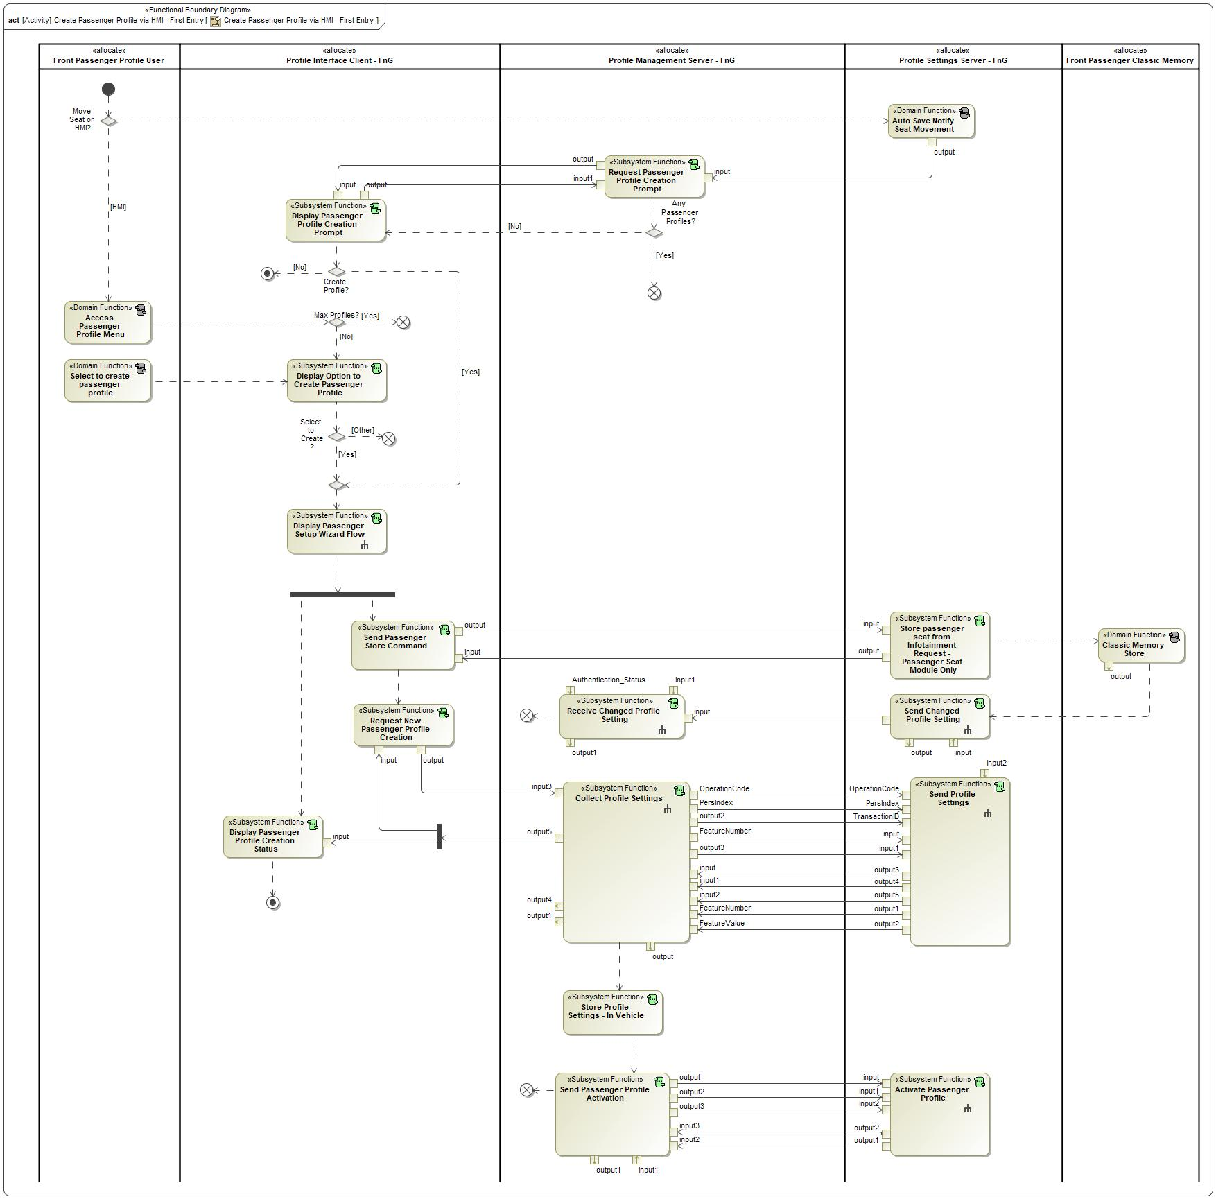

Figure 2: Activity Diagram of -556409490.jpg “Create Passenger Profile via HMI - First Entry” calling 2133516449.jpg “Display Option to Create Passenger Profile”

### Function Interfaces

#### Logical Inputs

No Logical Inputs specified.

#### Logical Outputs

No Logical Outputs specified.

#### Logical Parameters

*Not supported by MagicDraw report generation.*

### Function Modeling

#### Use Cases

*Not supported by MagicDraw report generation.*

#### State Charts / Activity Diagrams / Sequence Diagrams / Decision Tables

No diagrams internal to function specified.

### Function Requirements

#### Functional Requirements

##### Normal Operation

REQ-462310/A Create passenger profile menu option - maximum profiles reached

When the user accesses the passenger profile menu and the maximum amount of passenger profiles has been reached, the Profile Interface Client shall disable the option to create a new passenger profile.

|  |  |  |  |  |  |  |  |
| --- | --- | --- | --- | --- | --- | --- | --- |
| Requirement ID: | | | | | | | |
| **Rationale** |  | | | | | | |
| **Acceptance Criteria** |  | | | | | | |
| **Notes** |  | | | | | | |
| **Source** |  | | | | | **Owner** |  |
| **Source Req.** |  | | | | | **V&V Method** |  |
| **Type** |  | | | **Priority** |  | **Status** |  |
| [Req. Template](http://wiki.ford.com/display/RequirementsEngineering/Requirements+Attributes) Version | | 6.0 | End of Requirement | | | | |

REQ-462311/A Passenger Profile - Maximum Profiles

The Profile Interface Client shall define a configurable parameter called MaxPsngrProfile_Count, which defines the amount of passenger profiles that can be created.

|  |  |  |  |  |  |
| --- | --- | --- | --- | --- | --- |
| **Name** | **Description** | **Units** | **Range** | **Resolution** | **Default** |
| MaxPsngrProfile_Count | Maximum number of passenger profiles that can be created on a vehicle.  Note: Use the default value | - | 0-10 | 1 | 10 |

|  |  |  |  |  |  |  |  |
| --- | --- | --- | --- | --- | --- | --- | --- |
| Requirement ID: | | | | | | | |
| **Rationale** |  | | | | | | |
| **Acceptance Criteria** |  | | | | | | |
| **Notes** |  | | | | | | |
| **Source** |  | | | | | **Owner** |  |
| **Source Req.** |  | | | | | **V&V Method** |  |
| **Type** |  | | | **Priority** |  | **Status** |  |
| [Req. Template](http://wiki.ford.com/display/RequirementsEngineering/Requirements+Attributes) Version | | 6.0 | End of Requirement | | | | |

REQ-462309/A Create passenger profile menu option

When the user accesses the passenger profile menu and the maximum amount of passenger profiles has not been reached, the Profile Interface Client shall display an option to create a new passenger profile.

|  |  |  |  |  |  |  |  |
| --- | --- | --- | --- | --- | --- | --- | --- |
| Requirement ID: | | | | | | | |
| **Rationale** |  | | | | | | |
| **Acceptance Criteria** |  | | | | | | |
| **Notes** |  | | | | | | |
| **Source** |  | | | | | **Owner** |  |
| **Source Req.** |  | | | | | **V&V Method** |  |
| **Type** |  | | | **Priority** |  | **Status** |  |
| [Req. Template](http://wiki.ford.com/display/RequirementsEngineering/Requirements+Attributes) Version | | 6.0 | End of Requirement | | | | |

##### Error Handling

No Error Handling Requirements specified.

#### Non-Functional Requirements

No Non-Functional Requirements specified.

#### Functional Safety Requirements

No Functional Safety Requirements specified.

##### ASIL Decomposition of Functional Safety Requirements

No Functional Safety Requirements with ASIL Decompositions specified.

#### Other Requirements

##### Design Requirements

No Design Requirements specified.































## 873751927.jpg Display Passenger Profile Creation Prompt

### Function Overview

#### Description

Function is allocated to:

* 1716959969.jpg Front Passenger Profiles <<Feature>>
* 914643172.jpg Profile Interface Client - FnG <<Logical>>

HMI function to display a Passenger Profile Creation Prompt when there are no Passenger Profiles created.

#### Variants

*Not supported by MagicDraw report generation.*

#### Input Requirements

*Not supported by MagicDraw report generation.*

#### Assumptions

No assumptions specified for this function.

#### References

##### Ford Documents

List here all Ford internal documents, which are directly related to the feature.

| **Reference** | **Title** | **Doc. ID** | **Revision** |
| --- | --- | --- | --- |
|  |  |  |  |

Table 5: Ford internal Documents *(not specified in model)*

##### External Documents and Publications

The list of external documents could include books, reports and online sources.

| **Reference** | **Document / Publication** |
| --- | --- |
|  |  |

Table 7: External documents and publications *(not specified in model)*

#### Glossary

See Appendix for Definitions and Abbreviations.

### Function Scope

The 873751927.jpg **– “Display Passenger Profile Creation Prompt”** function is called by the following functions:

* -556409490.jpg – “Create Passenger Profile via HMI - First Entry”



Figure 2: Activity Diagram of -556409490.jpg “Create Passenger Profile via HMI - First Entry” calling 873751927.jpg “Display Passenger Profile Creation Prompt”

### Function Interfaces

#### Logical Inputs

|  |  |
| --- | --- |
| **Signal Name** | **Description** |
| input  Type:  -678216178.jpg PsngrProfilePrompt_Rq | Signal Description:  This signal relays a request from the Profile Management Server to the Profile Interface Client to display a Passenger Profile Creation Prompt.  Received from:   * 873751927.jpg Request Passenger Profile Creation Prompt |

#### Logical Outputs

|  |  |
| --- | --- |
| **Signal Name** | **Description** |
| output  Type:  -678216178.jpg PsngrProfilePrompt_St | Signal Description:  Status relayed to Profile Management Server based on user input.  Sent to:   * 873751927.jpg Request Passenger Profile Creation Prompt |

#### Logical Parameters

*Not supported by MagicDraw report generation.*

### Function Modeling

#### Use Cases

*Not supported by MagicDraw report generation.*

#### State Charts / Activity Diagrams / Sequence Diagrams / Decision Tables

No diagrams internal to function specified.

### Function Requirements

#### Functional Requirements

##### Normal Operation

REQ-462318/A Passenger Profile creation prompt

When the Profile Interface Client receives the PsngProfilePrompt_Rq, the Profile Interface Client shall display a prompt with the following selectable options:

- Yes

- No

- Do not show again

|  |  |  |  |  |  |  |  |
| --- | --- | --- | --- | --- | --- | --- | --- |
| Requirement ID: | | | | | | | |
| **Rationale** |  | | | | | | |
| **Acceptance Criteria** |  | | | | | | |
| **Notes** |  | | | | | | |
| **Source** |  | | | | | **Owner** |  |
| **Source Req.** |  | | | | | **V&V Method** |  |
| **Type** |  | | | **Priority** |  | **Status** |  |
| [Req. Template](http://wiki.ford.com/display/RequirementsEngineering/Requirements+Attributes) Version | | 6.0 | End of Requirement | | | | |

REQ-462321/A Responding to the PsngrProfilePrompt_Rq

When the user interacts with the Passenger Profile Creation Prompt, the Profile Interface Client shall send PsngrProfilePrompt_St to the Profile Management Server relaying the user input.

|  |  |  |  |  |  |  |  |
| --- | --- | --- | --- | --- | --- | --- | --- |
| Requirement ID: | | | | | | | |
| **Rationale** |  | | | | | | |
| **Acceptance Criteria** |  | | | | | | |
| **Notes** |  | | | | | | |
| **Source** |  | | | | | **Owner** |  |
| **Source Req.** |  | | | | | **V&V Method** |  |
| **Type** |  | | | **Priority** |  | **Status** |  |
| [Req. Template](http://wiki.ford.com/display/RequirementsEngineering/Requirements+Attributes) Version | | 6.0 | End of Requirement | | | | |

REQ-462320/A Entering passenger profile creation via prompt

When the user selects "Yes" on the passenger profile creation prompt, the Profile Interface Client shall enter the passenger profile creation flow.

|  |  |  |  |  |  |  |  |
| --- | --- | --- | --- | --- | --- | --- | --- |
| Requirement ID: | | | | | | | |
| **Rationale** |  | | | | | | |
| **Acceptance Criteria** |  | | | | | | |
| **Notes** |  | | | | | | |
| **Source** |  | | | | | **Owner** |  |
| **Source Req.** |  | | | | | **V&V Method** |  |
| **Type** |  | | | **Priority** |  | **Status** |  |
| [Req. Template](http://wiki.ford.com/display/RequirementsEngineering/Requirements+Attributes) Version | | 6.0 | End of Requirement | | | | |

REQ-462322/A Passenger Profile Creation Prompt time exceeds timeout limit

If the Passenger Profile Creation Prompt exceeds T_PsngrProfilePrompt, the Profile Interface Client shall remove the prompt from the display and send PsngrProfilePrompt_St = NO to the Profile Management Server.

|  |  |  |  |  |  |  |  |
| --- | --- | --- | --- | --- | --- | --- | --- |
| Requirement ID: | | | | | | | |
| **Rationale** |  | | | | | | |
| **Acceptance Criteria** |  | | | | | | |
| **Notes** |  | | | | | | |
| **Source** |  | | | | | **Owner** |  |
| **Source Req.** |  | | | | | **V&V Method** |  |
| **Type** |  | | | **Priority** |  | **Status** |  |
| [Req. Template](http://wiki.ford.com/display/RequirementsEngineering/Requirements+Attributes) Version | | 6.0 | End of Requirement | | | | |

##### Error Handling

No Error Handling Requirements specified.

#### Non-Functional Requirements

REQ-462319/A Passenger Profile creation prompt timeout limit

The Profile Interface Client shall display the passenger profile creation prompt for a maximum of T_PsngrProfilePrompt (Default = 8 seconds).

|  |  |  |  |  |  |  |  |
| --- | --- | --- | --- | --- | --- | --- | --- |
| Requirement ID: | | | | | | | |
| **Rationale** |  | | | | | | |
| **Acceptance Criteria** |  | | | | | | |
| **Notes** |  | | | | | | |
| **Source** |  | | | | | **Owner** |  |
| **Source Req.** |  | | | | | **V&V Method** |  |
| **Type** |  | | | **Priority** |  | **Status** |  |
| [Req. Template](http://wiki.ford.com/display/RequirementsEngineering/Requirements+Attributes) Version | | 6.0 | End of Requirement | | | | |

#### Functional Safety Requirements

No Functional Safety Requirements specified.

##### ASIL Decomposition of Functional Safety Requirements

No Functional Safety Requirements with ASIL Decompositions specified.

#### Other Requirements

##### Design Requirements

No Design Requirements specified.

## 873751927.jpg Display Passenger Profile Creation Status

### Function Overview

#### Description

Function is allocated to:

* 1716959969.jpg Front Passenger Profiles <<Feature>>
* 914643172.jpg Profile Interface Client - FnG <<Logical>>

HMI function that displays the status of a new Passenger Profile Creation.

#### Variants

*Not supported by MagicDraw report generation.*

#### Input Requirements

*Not supported by MagicDraw report generation.*

#### Assumptions

No assumptions specified for this function.

#### References

##### Ford Documents

List here all Ford internal documents, which are directly related to the feature.

| **Reference** | **Title** | **Doc. ID** | **Revision** |
| --- | --- | --- | --- |
|  |  |  |  |

Table 5: Ford internal Documents *(not specified in model)*

##### External Documents and Publications

The list of external documents could include books, reports and online sources.

| **Reference** | **Document / Publication** |
| --- | --- |
|  |  |

Table 7: External documents and publications *(not specified in model)*

#### Glossary

See Appendix for Definitions and Abbreviations.

### Function Scope

The 873751927.jpg **– “Display Passenger Profile Creation Status”** function is called by the following functions:

* -556409490.jpg – “Create Passenger Profile via HMI - First Entry”



Figure 2: Activity Diagram of -556409490.jpg “Create Passenger Profile via HMI - First Entry” calling 873751927.jpg “Display Passenger Profile Creation Status”

### Function Interfaces

#### Logical Inputs

|  |  |
| --- | --- |
| **Signal Name** | **Description** |
| input  Type:  -14943659.jpg pppStoreProfileData_Res | Signal Description:  Response to pppStoreProfileData_Rq indicating a Success or Failure.  Received from:   * -1965948643.jpg Collect Profile Settings |

#### Logical Outputs

No Logical Outputs specified.

#### Logical Parameters

*Not supported by MagicDraw report generation.*

### Function Modeling

#### Use Cases

*Not supported by MagicDraw report generation.*

#### State Charts / Activity Diagrams / Sequence Diagrams / Decision Tables

No diagrams internal to function specified.

### Function Requirements

#### Functional Requirements

##### Normal Operation

REQ-462327/A When to display Passenger Profile Complete Screen

When the Profile Interface Client receives pppStoreProfileData_Res = SUCCESS signal from the Profile Management Server indicating Passenger Profile setting collection has completed successfully, the Profile Interface Client shall display the Passenger Profile Complete screen.

|  |  |  |  |  |  |  |  |
| --- | --- | --- | --- | --- | --- | --- | --- |
| Requirement ID: | | | | | | | |
| **Rationale** |  | | | | | | |
| **Acceptance Criteria** |  | | | | | | |
| **Notes** |  | | | | | | |
| **Source** |  | | | | | **Owner** |  |
| **Source Req.** |  | | | | | **V&V Method** |  |
| **Type** |  | | | **Priority** |  | **Status** |  |
| [Req. Template](http://wiki.ford.com/display/RequirementsEngineering/Requirements+Attributes) Version | | 6.0 | End of Requirement | | | | |

REQ-462323/A When to display Compile Passenger Profile screen

After the user selects "Next" (or similar) on the Seat Configuration screen, the Profile Interface Client shall display the Compile Passenger Profile screen.

The Profile Interface Client shall exit the Compile Passenger Profile screen after receiving the pppStoreProfileData_Res signal from the Profile Management Server indicating that passenger profile collection has completed (Success or Fail).

|  |  |  |  |  |  |  |  |
| --- | --- | --- | --- | --- | --- | --- | --- |
| Requirement ID: | | | | | | | |
| **Rationale** |  | | | | | | |
| **Acceptance Criteria** |  | | | | | | |
| **Notes** |  | | | | | | |
| **Source** |  | | | | | **Owner** |  |
| **Source Req.** |  | | | | | **V&V Method** |  |
| **Type** |  | | | **Priority** |  | **Status** |  |
| [Req. Template](http://wiki.ford.com/display/RequirementsEngineering/Requirements+Attributes) Version | | 6.0 | End of Requirement | | | | |

##### Error Handling

REQ-462325/A Passenger Profile Creation Fail or Abort

If at any time during the Passenger Profile creation there is a failure or interruption, the Profile Interface Client shall notify the user that the process is aborted and shall provide the user the option to retry or cancel. Examples of failures and interruptions are below:

- Ignition Cycle

- Infotainment Reset

- High priority notification

- System failure collecting profile settings

- Etc.

|  |  |  |  |  |  |  |  |
| --- | --- | --- | --- | --- | --- | --- | --- |
| Requirement ID: | | | | | | | |
| **Rationale** |  | | | | | | |
| **Acceptance Criteria** |  | | | | | | |
| **Notes** |  | | | | | | |
| **Source** |  | | | | | **Owner** |  |
| **Source Req.** |  | | | | | **V&V Method** |  |
| **Type** |  | | | **Priority** |  | **Status** |  |
| [Req. Template](http://wiki.ford.com/display/RequirementsEngineering/Requirements+Attributes) Version | | 6.0 | End of Requirement | | | | |

#### Non-Functional Requirements

REQ-462324/A Content of the Compile Passenger Profile screen

The Profile Interface Client shall include the following while displaying the Passenger Compile Profile screen:

- Indicator that profile collection is in process (spinning wheel, status bar, etc.)

- Text notifying the user not to adjust and passenger profile settings while profile compiling is in process.

|  |  |  |  |  |  |  |  |
| --- | --- | --- | --- | --- | --- | --- | --- |
| Requirement ID: | | | | | | | |
| **Rationale** |  | | | | | | |
| **Acceptance Criteria** |  | | | | | | |
| **Notes** |  | | | | | | |
| **Source** |  | | | | | **Owner** |  |
| **Source Req.** |  | | | | | **V&V Method** |  |
| **Type** |  | | | **Priority** |  | **Status** |  |
| [Req. Template](http://wiki.ford.com/display/RequirementsEngineering/Requirements+Attributes) Version | | 6.0 | End of Requirement | | | | |

REQ-462326/A Duration of Passenger Profile Complete Screen

The Profile Interface Client shall display the Passenger Profile Complete screen until one of the following occur:

- User selects "Finish" (or similar)

- Screen displayed for 60 seconds

|  |  |  |  |  |  |  |  |
| --- | --- | --- | --- | --- | --- | --- | --- |
| Requirement ID: | | | | | | | |
| **Rationale** |  | | | | | | |
| **Acceptance Criteria** |  | | | | | | |
| **Notes** |  | | | | | | |
| **Source** |  | | | | | **Owner** |  |
| **Source Req.** |  | | | | | **V&V Method** |  |
| **Type** |  | | | **Priority** |  | **Status** |  |
| [Req. Template](http://wiki.ford.com/display/RequirementsEngineering/Requirements+Attributes) Version | | 6.0 | End of Requirement | | | | |

#### Functional Safety Requirements

No Functional Safety Requirements specified.

##### ASIL Decomposition of Functional Safety Requirements

No Functional Safety Requirements with ASIL Decompositions specified.

#### Other Requirements

##### Design Requirements

No Design Requirements specified.

## 873751927.jpg Display Passenger Profiles Menu

### Function Overview

#### Description

Function is allocated to:

* 1716959969.jpg Front Passenger Profiles <<Feature>>
* 914643172.jpg Profile Interface Client - FnG <<Logical>>

HMI function that displays all available Passenger Profiles.

#### Variants

*Not supported by MagicDraw report generation.*

#### Input Requirements

*Not supported by MagicDraw report generation.*

#### Assumptions

No assumptions specified for this function.

#### References

##### Ford Documents

List here all Ford internal documents, which are directly related to the feature.

| **Reference** | **Title** | **Doc. ID** | **Revision** |
| --- | --- | --- | --- |
|  |  |  |  |

Table 5: Ford internal Documents *(not specified in model)*

##### External Documents and Publications

The list of external documents could include books, reports and online sources.

| **Reference** | **Document / Publication** |
| --- | --- |
|  |  |

Table 7: External documents and publications *(not specified in model)*

#### Glossary

See Appendix for Definitions and Abbreviations.

### Function Scope

The 873751927.jpg **– “Display Passenger Profiles Menu”** function is called by the following functions:

* -556409490.jpg – “Delete Passenger Profile”
* -556409490.jpg – “Edit Front Passenger Name/Avatar”
* -556409490.jpg – “Manual Save Passenger Seat Position”
* -556409490.jpg – “Recall Passenger Profile”
* -556409490.jpg – “Reload Passenger Seat Position”



Figure 2: Activity Diagram of -556409490.jpg “Delete Passenger Profile” calling 873751927.jpg “Display Passenger Profiles Menu”

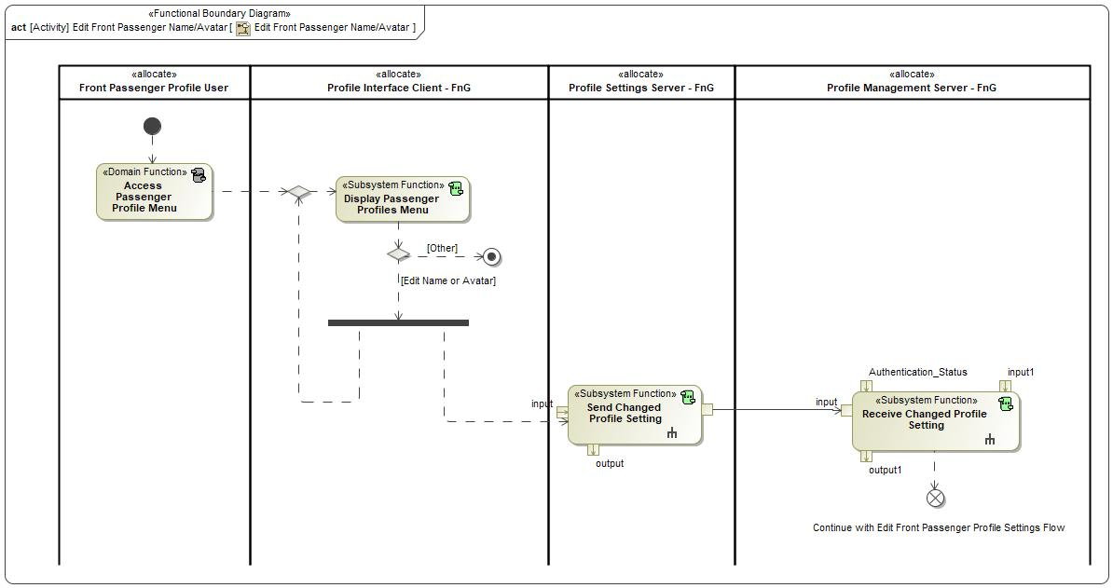

Figure 2: Activity Diagram of -556409490.jpg “Edit Front Passenger Name/Avatar” calling 873751927.jpg “Display Passenger Profiles Menu”

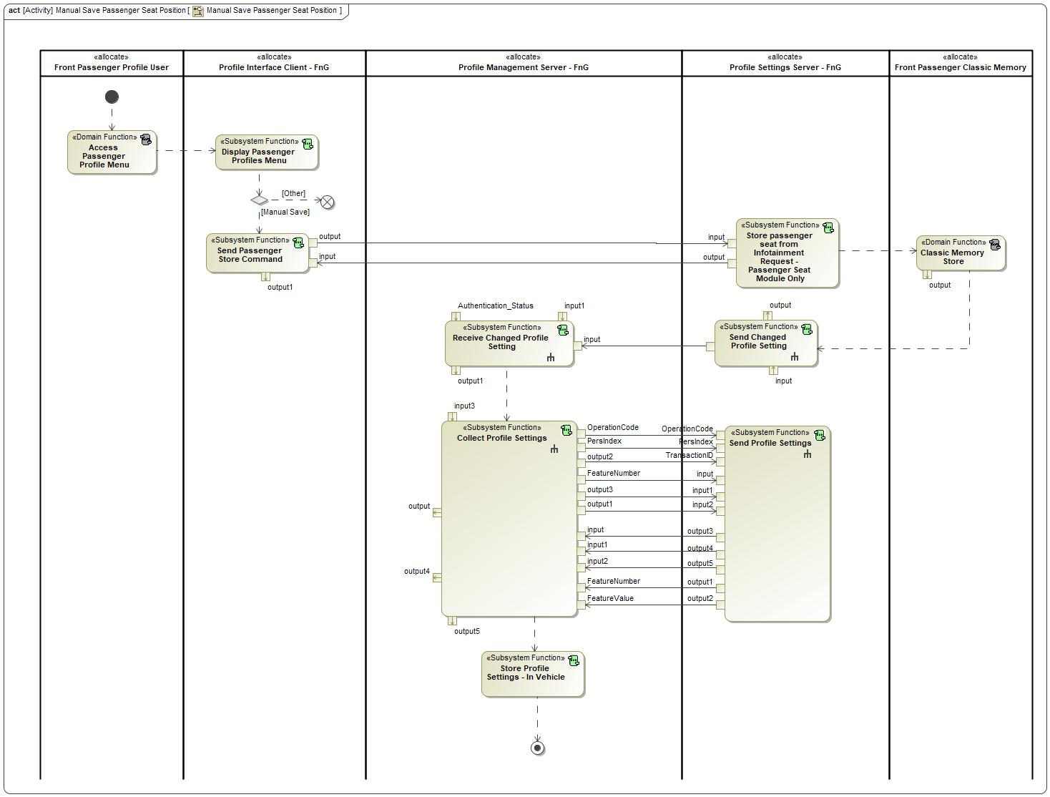

Figure 2: Activity Diagram of -556409490.jpg “Manual Save Passenger Seat Position” calling 873751927.jpg “Display Passenger Profiles Menu”



Figure 2: Activity Diagram of -556409490.jpg “Recall Passenger Profile” calling 873751927.jpg “Display Passenger Profiles Menu”



Figure 2: Activity Diagram of -556409490.jpg “Reload Passenger Seat Position” calling 873751927.jpg “Display Passenger Profiles Menu”

### Function Interfaces

#### Logical Inputs

No Logical Inputs specified.

#### Logical Outputs

No Logical Outputs specified.

#### Logical Parameters

*Not supported by MagicDraw report generation.*

### Function Modeling

#### Use Cases

*Not supported by MagicDraw report generation.*

#### State Charts / Activity Diagrams / Sequence Diagrams / Decision Tables

No diagrams internal to function specified.

### Function Requirements

#### Functional Requirements

##### Normal Operation

REQ-462336/A Send Activate command when Reload button pressed

When the Reload position button is pressed for a Passenger Profile, the Profile Interface Client shall send an Activate Passenger Profile request to the Profile Management Server for the requested profile.

|  |  |  |  |  |  |  |  |
| --- | --- | --- | --- | --- | --- | --- | --- |
| Requirement ID: | | | | | | | |
| **Rationale** |  | | | | | | |
| **Acceptance Criteria** |  | | | | | | |
| **Notes** |  | | | | | | |
| **Source** |  | | | | | **Owner** |  |
| **Source Req.** |  | | | | | **V&V Method** |  |
| **Type** |  | | | **Priority** |  | **Status** |  |
| [Req. Template](http://wiki.ford.com/display/RequirementsEngineering/Requirements+Attributes) Version | | 6.0 | End of Requirement | | | | |

REQ-462334/A Option to Reload Passenger seat position

The Profile Interface Client shall provide a method to reload the previously saved Passenger seat position for a profile when the following conditions are met:

- Active Passenger Profile menu open

- Unsaved passenger seat movement

If these conditions are not met, the Profile Interface Client shall disable the ability to Reload the Passenger Profile seats.

|  |  |  |  |  |  |  |  |
| --- | --- | --- | --- | --- | --- | --- | --- |
| Requirement ID: | | | | | | | |
| **Rationale** |  | | | | | | |
| **Acceptance Criteria** |  | | | | | | |
| **Notes** |  | | | | | | |
| **Source** |  | | | | | **Owner** |  |
| **Source Req.** |  | | | | | **V&V Method** |  |
| **Type** |  | | | **Priority** |  | **Status** |  |
| [Req. Template](http://wiki.ford.com/display/RequirementsEngineering/Requirements+Attributes) Version | | 6.0 | End of Requirement | | | | |

REQ-462329/A Option to Delete Passenger Profile

The Profile Interface Client shall provide a method for the user to delete a Passenger Profile from the Passenger Profile Menu.

|  |  |  |  |  |  |  |  |
| --- | --- | --- | --- | --- | --- | --- | --- |
| Requirement ID: | | | | | | | |
| **Rationale** |  | | | | | | |
| **Acceptance Criteria** |  | | | | | | |
| **Notes** |  | | | | | | |
| **Source** |  | | | | | **Owner** |  |
| **Source Req.** |  | | | | | **V&V Method** |  |
| **Type** |  | | | **Priority** |  | **Status** |  |
| [Req. Template](http://wiki.ford.com/display/RequirementsEngineering/Requirements+Attributes) Version | | 6.0 | End of Requirement | | | | |

REQ-462328/A Displaying available passenger profiles

The Profile Interface Client shall provide a method to display all available Passenger Profiles.

|  |  |  |  |  |  |  |  |
| --- | --- | --- | --- | --- | --- | --- | --- |
| Requirement ID: | | | | | | | |
| **Rationale** |  | | | | | | |
| **Acceptance Criteria** |  | | | | | | |
| **Notes** |  | | | | | | |
| **Source** |  | | | | | **Owner** |  |
| **Source Req.** |  | | | | | **V&V Method** |  |
| **Type** |  | | | **Priority** |  | **Status** |  |
| [Req. Template](http://wiki.ford.com/display/RequirementsEngineering/Requirements+Attributes) Version | | 6.0 | End of Requirement | | | | |

REQ-462337/A Option to Recall Passenger Profile

The Profile Interface Client shall provide a method to recall any available Passenger Profiles.

|  |  |  |  |  |  |  |  |
| --- | --- | --- | --- | --- | --- | --- | --- |
| Requirement ID: | | | | | | | |
| **Rationale** |  | | | | | | |
| **Acceptance Criteria** |  | | | | | | |
| **Notes** |  | | | | | | |
| **Source** |  | | | | | **Owner** |  |
| **Source Req.** |  | | | | | **V&V Method** |  |
| **Type** |  | | | **Priority** |  | **Status** |  |
| [Req. Template](http://wiki.ford.com/display/RequirementsEngineering/Requirements+Attributes) Version | | 6.0 | End of Requirement | | | | |



REQ-462333/A Option to Manually Save Passenger Profile seats

The Profile Interface Client shall provide a method to manually save the Passenger seats for a profile when the following conditions are met:

- Active Passenger Profile menu open

- Unsaved passenger seat movement

If these conditions are not met, the Profile Interface Client shall disable the ability to Manually save the Passenger Profile seats.

|  |  |  |  |  |  |  |  |
| --- | --- | --- | --- | --- | --- | --- | --- |
| Requirement ID: | | | | | | | |
| **Rationale** |  | | | | | | |
| **Acceptance Criteria** |  | | | | | | |
| **Notes** |  | | | | | | |
| **Source** |  | | | | | **Owner** |  |
| **Source Req.** |  | | | | | **V&V Method** |  |
| **Type** |  | | | **Priority** |  | **Status** |  |
| [Req. Template](http://wiki.ford.com/display/RequirementsEngineering/Requirements+Attributes) Version | | 6.0 | End of Requirement | | | | |

REQ-462330/A Option to Edit Passenger Profile Username

The Profile Interface Client shall provide a method for a user to edit the username of pre-existing Passenger Profiles.

|  |  |  |  |  |  |  |  |
| --- | --- | --- | --- | --- | --- | --- | --- |
| Requirement ID: | | | | | | | |
| **Rationale** |  | | | | | | |
| **Acceptance Criteria** |  | | | | | | |
| **Notes** |  | | | | | | |
| **Source** |  | | | | | **Owner** |  |
| **Source Req.** |  | | | | | **V&V Method** |  |
| **Type** |  | | | **Priority** |  | **Status** |  |
| [Req. Template](http://wiki.ford.com/display/RequirementsEngineering/Requirements+Attributes) Version | | 6.0 | End of Requirement | | | | |

REQ-462331/A Option to Edit Passenger Profile Avatar

The Profile Interface Client shall provide a method for a user to edit the avatar of pre-existing Passenger Profiles.

|  |  |  |  |  |  |  |  |
| --- | --- | --- | --- | --- | --- | --- | --- |
| Requirement ID: | | | | | | | |
| **Rationale** |  | | | | | | |
| **Acceptance Criteria** |  | | | | | | |
| **Notes** |  | | | | | | |
| **Source** |  | | | | | **Owner** |  |
| **Source Req.** |  | | | | | **V&V Method** |  |
| **Type** |  | | | **Priority** |  | **Status** |  |
| [Req. Template](http://wiki.ford.com/display/RequirementsEngineering/Requirements+Attributes) Version | | 6.0 | End of Requirement | | | | |

REQ-462332/A Option to Edit Passenger Profile Seat Memory Settings

The Profile Interface Client shall provide a method for a user to edit the Seat Memory Settings (Auto Save Toggle) of pre-existing Passenger Profiles.

|  |  |  |  |  |  |  |  |
| --- | --- | --- | --- | --- | --- | --- | --- |
| Requirement ID: | | | | | | | |
| **Rationale** |  | | | | | | |
| **Acceptance Criteria** |  | | | | | | |
| **Notes** |  | | | | | | |
| **Source** |  | | | | | **Owner** |  |
| **Source Req.** |  | | | | | **V&V Method** |  |
| **Type** |  | | | **Priority** |  | **Status** |  |
| [Req. Template](http://wiki.ford.com/display/RequirementsEngineering/Requirements+Attributes) Version | | 6.0 | End of Requirement | | | | |

REQ-462317/A Exiting the Passenger Edit Profile Screen

When the user selects to Exit the Passenger Profile Edit screen, the Profile Interface Client shall return to the Passenger Profile menu.

|  |  |  |  |  |  |  |  |
| --- | --- | --- | --- | --- | --- | --- | --- |
| Requirement ID: | | | | | | | |
| **Rationale** |  | | | | | | |
| **Acceptance Criteria** |  | | | | | | |
| **Notes** |  | | | | | | |
| **Source** |  | | | | | **Owner** |  |
| **Source Req.** |  | | | | | **V&V Method** |  |
| **Type** |  | | | **Priority** |  | **Status** |  |
| [Req. Template](http://wiki.ford.com/display/RequirementsEngineering/Requirements+Attributes) Version | | 6.0 | End of Requirement | | | | |

REQ-462312/A Display during Passenger Avatar edit

When the user selects to edit their Passenger Profile Avater, the Profile Interface Client shall display the Passenger Avatar screen with the option to select a different Avatar.

|  |  |  |  |  |  |  |  |
| --- | --- | --- | --- | --- | --- | --- | --- |
| Requirement ID: | | | | | | | |
| **Rationale** |  | | | | | | |
| **Acceptance Criteria** |  | | | | | | |
| **Notes** |  | | | | | | |
| **Source** |  | | | | | **Owner** |  |
| **Source Req.** |  | | | | | **V&V Method** |  |
| **Type** |  | | | **Priority** |  | **Status** |  |
| [Req. Template](http://wiki.ford.com/display/RequirementsEngineering/Requirements+Attributes) Version | | 6.0 | End of Requirement | | | | |

REQ-462313/A Exiting Passenger Avatar screen during profile edit

When the user selects to exit the Passenger Avatar screen when editing their profile, the Profile Interface Client shall return to the Passenger Profile Edit screen.

|  |  |  |  |  |  |  |  |
| --- | --- | --- | --- | --- | --- | --- | --- |
| Requirement ID: | | | | | | | |
| **Rationale** |  | | | | | | |
| **Acceptance Criteria** |  | | | | | | |
| **Notes** |  | | | | | | |
| **Source** |  | | | | | **Owner** |  |
| **Source Req.** |  | | | | | **V&V Method** |  |
| **Type** |  | | | **Priority** |  | **Status** |  |
| [Req. Template](http://wiki.ford.com/display/RequirementsEngineering/Requirements+Attributes) Version | | 6.0 | End of Requirement | | | | |

REQ-462315/A Exiting Passenger Username screen during profile edit

When the user selects to exit the Passenger Username screen when editing their profile, the Profile Interface Client shall return to the Passenger Profile Edit screen.

|  |  |  |  |  |  |  |  |
| --- | --- | --- | --- | --- | --- | --- | --- |
| Requirement ID: | | | | | | | |
| **Rationale** |  | | | | | | |
| **Acceptance Criteria** |  | | | | | | |
| **Notes** |  | | | | | | |
| **Source** |  | | | | | **Owner** |  |
| **Source Req.** |  | | | | | **V&V Method** |  |
| **Type** |  | | | **Priority** |  | **Status** |  |
| [Req. Template](http://wiki.ford.com/display/RequirementsEngineering/Requirements+Attributes) Version | | 6.0 | End of Requirement | | | | |

REQ-462314/A Display during Passenger username edit

When the user selects to edit their profile username, the Profile Interface Client shall display the Passenger Username screen with the option to edit the username.

|  |  |  |  |  |  |  |  |
| --- | --- | --- | --- | --- | --- | --- | --- |
| Requirement ID: | | | | | | | |
| **Rationale** |  | | | | | | |
| **Acceptance Criteria** |  | | | | | | |
| **Notes** |  | | | | | | |
| **Source** |  | | | | | **Owner** |  |
| **Source Req.** |  | | | | | **V&V Method** |  |
| **Type** |  | | | **Priority** |  | **Status** |  |
| [Req. Template](http://wiki.ford.com/display/RequirementsEngineering/Requirements+Attributes) Version | | 6.0 | End of Requirement | | | | |

REQ-462316/A Passenger Profile Edit Screen Content

The Profile Interface Client shall display options for the following content when the user is editing a Passenger Profile:

- Edit Username

- Edit Avatar

- Edit AutoSave Toggle

- Exit Edit Screen button

|  |  |  |  |  |  |  |  |
| --- | --- | --- | --- | --- | --- | --- | --- |
| Requirement ID: | | | | | | | |
| **Rationale** |  | | | | | | |
| **Acceptance Criteria** |  | | | | | | |
| **Notes** |  | | | | | | |
| **Source** |  | | | | | **Owner** |  |
| **Source Req.** |  | | | | | **V&V Method** |  |
| **Type** |  | | | **Priority** |  | **Status** |  |
| [Req. Template](http://wiki.ford.com/display/RequirementsEngineering/Requirements+Attributes) Version | | 6.0 | End of Requirement | | | | |

##### Error Handling

No Error Handling Requirements specified.

#### Non-Functional Requirements

No Non-Functional Requirements specified.

#### Functional Safety Requirements

No Functional Safety Requirements specified.

##### ASIL Decomposition of Functional Safety Requirements

No Functional Safety Requirements with ASIL Decompositions specified.

#### Other Requirements

##### Design Requirements

No Design Requirements specified.

## 873751927.jpg Display Passenger Setup Wizard Flow

### Function Overview

#### Description

Function is allocated to:

* 1716959969.jpg Front Passenger Profiles <<Feature>>
* 914643172.jpg Profile Interface Client - FnG <<Logical>>

HMI function that navigates the user through a Passenger Profile Creation Setup Wizard.

#### Variants

*Not supported by MagicDraw report generation.*

#### Input Requirements

*Not supported by MagicDraw report generation.*

#### Assumptions

No assumptions specified for this function.

#### References

##### Ford Documents

List here all Ford internal documents, which are directly related to the feature.

| **Reference** | **Title** | **Doc. ID** | **Revision** |
| --- | --- | --- | --- |
|  |  |  |  |

Table 5: Ford internal Documents *(not specified in model)*

##### External Documents and Publications

The list of external documents could include books, reports and online sources.

| **Reference** | **Document / Publication** |
| --- | --- |
|  |  |

Table 7: External documents and publications *(not specified in model)*

#### Glossary

See Appendix for Definitions and Abbreviations.

### Function Scope

The 873751927.jpg **– “Display Passenger Setup Wizard Flow”** function is called by the following functions:

* -556409490.jpg – “Create Passenger Profile via HMI - First Entry”



Figure 2: Activity Diagram of -556409490.jpg “Create Passenger Profile via HMI - First Entry” calling 873751927.jpg “Display Passenger Setup Wizard Flow”

### Function Interfaces

#### Logical Inputs

|  |  |
| --- | --- |
|  |  |
|  |  |

|  |  |
| --- | --- |
|  |  |
|  |  |

#### Logical Parameters

*Not supported by MagicDraw report generation.*

### Function Modeling

#### Use Cases

*Not supported by MagicDraw report generation.*

#### State Charts / Activity Diagrams / Sequence Diagrams / Decision Tables

### Function Requirements

#### Functional Requirements

##### Normal Operation

|  |  |  |  |  |  |  |  |
| --- | --- | --- | --- | --- | --- | --- | --- |
|  | | | | | | | |
|  |  | | | | | | |
|  |  | | | | | | |
|  |  | | | | | | |
|  |  | | | | |  |  |
|  |  | | | | |  |  |
|  |  | | |  |  |  |  |
|  | |  |  | | | | |

REQ-462344/A Display during passenger profile creation - Avatar

After the user selects "Next" (or similar) on the Passenger Username screen during Passenger Profile creation flow, the Profile Interface Client shall display the Passenger Avatar selection screen.

|  |  |  |  |  |  |  |  |
| --- | --- | --- | --- | --- | --- | --- | --- |
| Requirement ID: | | | | | | | |
| **Rationale** |  | | | | | | |
| **Acceptance Criteria** |  | | | | | | |
| **Notes** |  | | | | | | |
| **Source** |  | | | | | **Owner** |  |
| **Source Req.** |  | | | | | **V&V Method** |  |
| **Type** |  | | | **Priority** |  | **Status** |  |
| [Req. Template](http://wiki.ford.com/display/RequirementsEngineering/Requirements+Attributes) Version | | 6.0 | End of Requirement | | | | |

REQ-462346/A Passenger Avatar selections

All Passenger Profile Avatars shall be pre-stored and provided by the Profile Interface Client.

|  |  |  |  |  |  |  |  |
| --- | --- | --- | --- | --- | --- | --- | --- |
| Requirement ID: | | | | | | | |
| **Rationale** |  | | | | | | |
| **Acceptance Criteria** |  | | | | | | |
| **Notes** |  | | | | | | |
| **Source** |  | | | | | **Owner** |  |
| **Source Req.** |  | | | | | **V&V Method** |  |
| **Type** |  | | | **Priority** |  | **Status** |  |
| [Req. Template](http://wiki.ford.com/display/RequirementsEngineering/Requirements+Attributes) Version | | 6.0 | End of Requirement | | | | |

REQ-462343/A One Avatar per Passenger Profile

The Profile Interface Client shall allow the user to select ONE Passenger Avatar for their Passenger Profile.

|  |  |  |  |  |  |  |  |
| --- | --- | --- | --- | --- | --- | --- | --- |
| Requirement ID: | | | | | | | |
| **Rationale** |  | | | | | | |
| **Acceptance Criteria** |  | | | | | | |
| **Notes** |  | | | | | | |
| **Source** |  | | | | | **Owner** |  |
| **Source Req.** |  | | | | | **V&V Method** |  |
| **Type** |  | | | **Priority** |  | **Status** |  |
| [Req. Template](http://wiki.ford.com/display/RequirementsEngineering/Requirements+Attributes) Version | | 6.0 | End of Requirement | | | | |

REQ-462340/A Display during Passenger profile creation flow - Seat Configuration

After the user selects "Next" (or similar) on the Passenger Avatar screen during Passenger Profile creation flow, the Profile Interface Client shall display the Passenger Seat Configuration screen.

|  |  |  |  |  |  |  |  |
| --- | --- | --- | --- | --- | --- | --- | --- |
| Requirement ID: | | | | | | | |
| **Rationale** |  | | | | | | |
| **Acceptance Criteria** |  | | | | | | |
| **Notes** |  | | | | | | |
| **Source** |  | | | | | **Owner** |  |
| **Source Req.** |  | | | | | **V&V Method** |  |
| **Type** |  | | | **Priority** |  | **Status** |  |
| [Req. Template](http://wiki.ford.com/display/RequirementsEngineering/Requirements+Attributes) Version | | 6.0 | End of Requirement | | | | |

REQ-462345/A Passenger Avatar selection indicator

While on the Passenger Avatar screen, the Profile Interface Client shall indicate which Avatar is currently selected.

|  |  |  |  |  |  |  |  |
| --- | --- | --- | --- | --- | --- | --- | --- |
| Requirement ID: | | | | | | | |
| **Rationale** |  | | | | | | |
| **Acceptance Criteria** |  | | | | | | |
| **Notes** |  | | | | | | |
| **Source** |  | | | | | **Owner** |  |
| **Source Req.** |  | | | | | **V&V Method** |  |
| **Type** |  | | | **Priority** |  | **Status** |  |
| [Req. Template](http://wiki.ford.com/display/RequirementsEngineering/Requirements+Attributes) Version | | 6.0 | End of Requirement | | | | |

REQ-462342/A Passenger Setup Wizard Flow Content

When the user enters the Passenger Setup Wizard flow by selecting to create a new Passenger Profile, the Profile Interface Client shall provide the following content in the Passenger Setup Wizard:

- Username Screen

- Avatar Selection Screen

- Seat Configuration Screen

|  |  |  |  |  |  |  |  |
| --- | --- | --- | --- | --- | --- | --- | --- |
| Requirement ID: | | | | | | | |
| **Rationale** |  | | | | | | |
| **Acceptance Criteria** |  | | | | | | |
| **Notes** |  | | | | | | |
| **Source** |  | | | | | **Owner** |  |
| **Source Req.** |  | | | | | **V&V Method** |  |
| **Type** |  | | | **Priority** |  | **Status** |  |
| [Req. Template](http://wiki.ford.com/display/RequirementsEngineering/Requirements+Attributes) Version | | 6.0 | End of Requirement | | | | |

REQ-462349/A Display during passenger profile creation - Username

When the Profile Interface Client enters passenger profile creation, the Profile Interface Client shall first display the passenger username screen.

|  |  |  |  |  |  |  |  |
| --- | --- | --- | --- | --- | --- | --- | --- |
| Requirement ID: | | | | | | | |
| **Rationale** |  | | | | | | |
| **Acceptance Criteria** |  | | | | | | |
| **Notes** |  | | | | | | |
| **Source** |  | | | | | **Owner** |  |
| **Source Req.** |  | | | | | **V&V Method** |  |
| **Type** |  | | | **Priority** |  | **Status** |  |
| [Req. Template](http://wiki.ford.com/display/RequirementsEngineering/Requirements+Attributes) Version | | 6.0 | End of Requirement | | | | |

REQ-462347/A Entered Passenger Username not unique

If the entered Passenger Profile Username is not unique:

- The Profile Interface Client shall provide notification to the user that the name already exists

- The Profile Interface Client shall not allow the existing name be overwritten

- The Profile Interface Client shall provide the user retry opportunity until an unique name is entered before proceeding to next step

|  |  |  |  |  |  |  |  |
| --- | --- | --- | --- | --- | --- | --- | --- |
| Requirement ID: | | | | | | | |
| **Rationale** |  | | | | | | |
| **Acceptance Criteria** |  | | | | | | |
| **Notes** |  | | | | | | |
| **Source** |  | | | | | **Owner** |  |
| **Source Req.** |  | | | | | **V&V Method** |  |
| **Type** |  | | | **Priority** |  | **Status** |  |
| [Req. Template](http://wiki.ford.com/display/RequirementsEngineering/Requirements+Attributes) Version | | 6.0 | End of Requirement | | | | |

|  |  |  |  |  |  |  |  |
| --- | --- | --- | --- | --- | --- | --- | --- |
|  | | | | | | | |
|  |  | | | | | | |
|  |  | | | | | | |
|  |  | | | | | | |
|  |  | | | | |  |  |
|  |  | | | | |  |  |
|  |  | | |  |  |  |  |
|  | |  |  | | | | |

##### Error Handling

No Error Handling Requirements specified.

#### Non-Functional Requirements

REQ-462341/A Content of the Passenger Seat Configuration screen

The Profile Interface Client shall include the following on the Passenger Seat Configuration screen:

- instructions on configuring passenger seat position

- "Next" (or similar) button

|  |  |  |  |  |  |  |  |
| --- | --- | --- | --- | --- | --- | --- | --- |
| Requirement ID: | | | | | | | |
| **Rationale** |  | | | | | | |
| **Acceptance Criteria** |  | | | | | | |
| **Notes** |  | | | | | | |
| **Source** |  | | | | | **Owner** |  |
| **Source Req.** |  | | | | | **V&V Method** |  |
| **Type** |  | | | **Priority** |  | **Status** |  |
| [Req. Template](http://wiki.ford.com/display/RequirementsEngineering/Requirements+Attributes) Version | | 6.0 | End of Requirement | | | | |

REQ-462348/A Passenger username requirements

The Passenger Profile username shall abide by the following restrictions:

- Passenger username shall be unique

- The length of each Passenger Profile name shall be at least 1 character in length, but no more than 32 characters.

- The Passenger Profile Name must begin with an alphabetic character.

- The button used to enter the Passenger Profile Name and continue to the next screen shall be made inactive (inoperable) until the Passenger Profile Name meets the above conditions.

- The keyboard used to enter the Passenger Profile Name shall stop accepting character input when the maximum character limit has been reached.

|  |  |  |  |  |  |  |  |
| --- | --- | --- | --- | --- | --- | --- | --- |
| Requirement ID: | | | | | | | |
| **Rationale** |  | | | | | | |
| **Acceptance Criteria** |  | | | | | | |
| **Notes** |  | | | | | | |
| **Source** |  | | | | | **Owner** |  |
| **Source Req.** |  | | | | | **V&V Method** |  |
| **Type** |  | | | **Priority** |  | **Status** |  |
| [Req. Template](http://wiki.ford.com/display/RequirementsEngineering/Requirements+Attributes) Version | | 6.0 | End of Requirement | | | | |

#### Functional Safety Requirements

No Functional Safety Requirements specified.

##### ASIL Decomposition of Functional Safety Requirements

No Functional Safety Requirements with ASIL Decompositions specified.

#### Other Requirements

##### Design Requirements

No Design Requirements specified.































## 873751927.jpg Lockout Profile for Download

### Function Overview

#### Description

Function is allocated to:

* 938416679.jpg Lockout Profile for Download - APIM <<Logical>>
* 914643172.jpg Profile Interface Client - FnG <<Logical>>

This function is allocated to the Profile Interface Client and provides an HMI graphic that locks out the HMI screen so that the customer cannot make any changes while the PPP feature is applying settings.

#### Variants

*Not supported by MagicDraw report generation.*

#### Input Requirements

*Not supported by MagicDraw report generation.*

#### Assumptions

No assumptions specified for this function.

#### References

##### Ford Documents

List here all Ford internal documents, which are directly related to the feature.

| **Reference** | **Title** | **Doc. ID** | **Revision** |
| --- | --- | --- | --- |
|  |  |  |  |

Table 5: Ford internal Documents *(not specified in model)*

##### External Documents and Publications

The list of external documents could include books, reports and online sources.

| **Reference** | **Document / Publication** |
| --- | --- |
|  |  |

Table 7: External documents and publications *(not specified in model)*

#### Glossary

See Appendix for Definitions and Abbreviations.

### Function Scope

The 873751927.jpg **– “Lockout Profile for Download”** function is called by the following functions:

* -556409490.jpg – “1 Link New Vehicle Profile w/ FP Account”
* -556409490.jpg – “2 Link Pre-existing Vehicle Profile w/ FP account”



Figure 2: Activity Diagram of -556409490.jpg “1 Link New Vehicle Profile w/ FP Account” calling 873751927.jpg “Lockout Profile for Download”



Figure 2: Activity Diagram of -556409490.jpg “2 Link Pre-existing Vehicle Profile w/ FP account” calling 873751927.jpg “Lockout Profile for Download”

### Function Interfaces

#### Logical Inputs

|  |  |
| --- | --- |
| **Signal Name** | **Description** |
| pppImportStatusBroadcast  Type:  -678216178.jpg pppImportStatusBroadcast | Signal Description:  A command sent to the Profile Interface Client when the Profile Management Server is actively downloading and applying profile data. Signal prompts Profile Interface Client to display a lockout screen and communicate status.  Received from:   * 873751927.jpg Collect Profile Settings * 873751927.jpg Push Profile Settings |

#### Logical Outputs

No Logical Outputs specified.

#### Logical Parameters

*Not supported by MagicDraw report generation.*

### Function Modeling

#### Use Cases

*Not supported by MagicDraw report generation.*

#### State Charts / Activity Diagrams / Sequence Diagrams / Decision Tables

No diagrams internal to function specified.

### Function Requirements

#### Functional Requirements

##### Normal Operation

REQ-460544/A Updating Download Lockout Screen

The Profile Interface Client shall update the Download Lockout screen based on the status received in pppImportStatusBroadcast.

|  |  |  |  |  |  |  |  |
| --- | --- | --- | --- | --- | --- | --- | --- |
| Requirement ID: REQ-460544/A | | | | | | | |
| **Rationale** |  | | | | | | |
| **Acceptance Criteria** |  | | | | | | |
| **Notes** |  | | | | | | |
| **Source** |  | | | | | **Owner** |  |
| **Source Req.** |  | | | | | **V&V Method** |  |
| **Type** |  | | | **Priority** |  | **Status** |  |
| [Req. Template](http://wiki.ford.com/display/RequirementsEngineering/Requirements+Attributes) Version | | 6.0 | End of Requirement | | | | |

REQ-460545/A Duration of lockout screen

The Profile Interface Client shall display the download lockout screen until one of the following conditions are met:

- pppImportStatusBroadcast = Complete - Success

- pppUpdateWizardSettings = No Profile

- Vehicle transitioned out of PARK

- Vehicle ignition switched from ON to OFF

|  |  |  |  |  |  |  |  |
| --- | --- | --- | --- | --- | --- | --- | --- |
| Requirement ID: REQ-460545/A | | | | | | | |
| **Rationale** |  | | | | | | |
| **Acceptance Criteria** |  | | | | | | |
| **Notes** |  | | | | | | |
| **Source** |  | | | | | **Owner** |  |
| **Source Req.** |  | | | | | **V&V Method** |  |
| **Type** |  | | | **Priority** |  | **Status** |  |
| [Req. Template](http://wiki.ford.com/display/RequirementsEngineering/Requirements+Attributes) Version | | 6.0 | End of Requirement | | | | |

REQ-460546/A Displaying the Download Lockout Screen

During Profile creation and after the Profile Interface Client receives pppProfileID_Res = OK, the Profile Interface Client shall display the Download Lockout Screen.

|  |  |  |  |  |  |  |  |
| --- | --- | --- | --- | --- | --- | --- | --- |
| Requirement ID: REQ-460546/A | | | | | | | |
| **Rationale** |  | | | | | | |
| **Acceptance Criteria** |  | | | | | | |
| **Notes** |  | | | | | | |
| **Source** |  | | | | | **Owner** |  |
| **Source Req.** |  | | | | | **V&V Method** |  |
| **Type** |  | | | **Priority** |  | **Status** |  |
| [Req. Template](http://wiki.ford.com/display/RequirementsEngineering/Requirements+Attributes) Version | | 6.0 | End of Requirement | | | | |

REQ-460547/A Sending recall request after Download Lockout Screen

When the Profile Interface Client receives pppImportStatusBroadcast = Complete - Success, the Profile Interface Client shall issue a recall request of the profile being created or edited.

|  |  |  |  |  |  |  |  |
| --- | --- | --- | --- | --- | --- | --- | --- |
| Requirement ID: REQ-460547/A | | | | | | | |
| **Rationale** |  | | | | | | |
| **Acceptance Criteria** |  | | | | | | |
| **Notes** |  | | | | | | |
| **Source** |  | | | | | **Owner** |  |
| **Source Req.** |  | | | | | **V&V Method** |  |
| **Type** |  | | | **Priority** |  | **Status** |  |
| [Req. Template](http://wiki.ford.com/display/RequirementsEngineering/Requirements+Attributes) Version | | 6.0 | End of Requirement | | | | |

##### Error Handling

No Error Handling Requirements specified.

#### Non-Functional Requirements

No Non-Functional Requirements specified.

#### Functional Safety Requirements

No Functional Safety Requirements specified.

##### ASIL Decomposition of Functional Safety Requirements

No Functional Safety Requirements with ASIL Decompositions specified.

#### Other Requirements

##### Design Requirements

No Design Requirements specified.

## 873751927.jpg Primary Authentication

### Function Overview

#### Description

Function is allocated to:

* 914643172.jpg Profile Interface Client - FnG <<Logical>>
* 938416679.jpg Setup Primary Authentication - APIM <<Logical>>

This is an HMI function that allows the user to setup their primary authentication method for their profile.

#### Variants

*Not supported by MagicDraw report generation.*

#### Input Requirements

*Not supported by MagicDraw report generation.*

#### Assumptions

No assumptions specified for this function.

#### References

##### Ford Documents

List here all Ford internal documents, which are directly related to the feature.

| **Reference** | **Title** | **Doc. ID** | **Revision** |
| --- | --- | --- | --- |
|  |  |  |  |

Table 5: Ford internal Documents *(not specified in model)*

##### External Documents and Publications

The list of external documents could include books, reports and online sources.

| **Reference** | **Document / Publication** |
| --- | --- |
|  |  |

Table 7: External documents and publications *(not specified in model)*

#### Glossary

See Appendix for Definitions and Abbreviations.

### Function Scope

The 873751927.jpg **– “Primary Authentication”** function is called by the following functions:

* -556409490.jpg – “1 Link New Vehicle Profile w/ FP Account”
* -556409490.jpg – “7 Synchronize Profile with the Cloud”
* -556409490.jpg – “15 Restore Changed Profile”



Figure 2: Activity Diagram of -556409490.jpg “1 Link New Vehicle Profile w/ FP Account” calling 873751927.jpg “Primary Authentication”

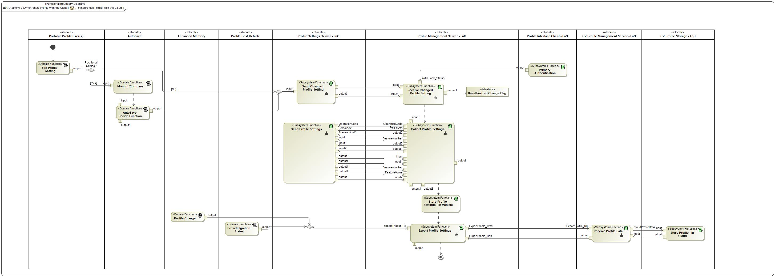

Figure 2: Activity Diagram of -556409490.jpg “7 Synchronize Profile with the Cloud” calling 873751927.jpg “Primary Authentication”

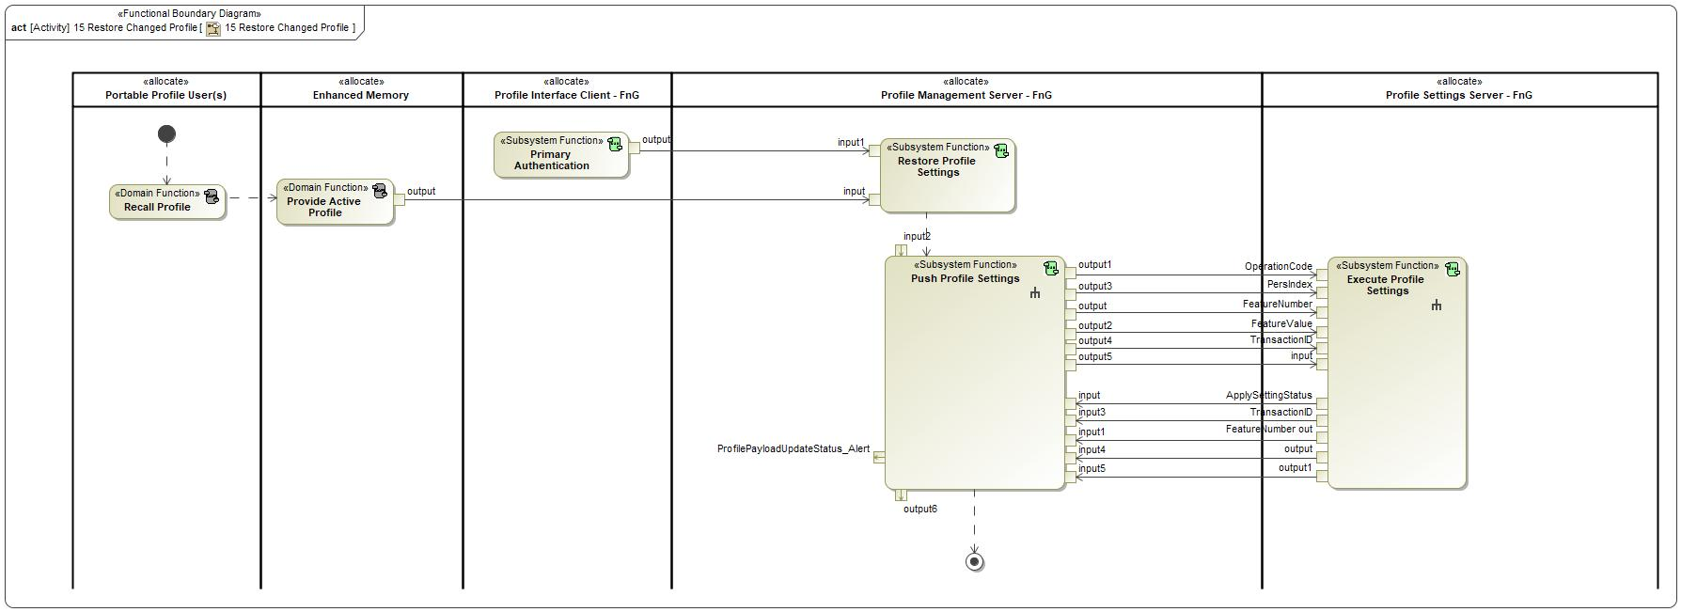

Figure 2: Activity Diagram of -556409490.jpg “15 Restore Changed Profile” calling 873751927.jpg “Primary Authentication”

### Function Interfaces

#### Logical Inputs

No Logical Inputs specified.

#### Logical Outputs

|  |  |
| --- | --- |
| **Signal Name** | **Description** |
| output  Type:  -678216178.jpg ProfileLock_Status | Signal Description:  Internal vehicle status that broadcasts if a profile is authenticated or not. Profile Management Server is the transmitter of the signal and the receiver is the Profile Interface Client.  Sent to:   * 873751927.jpg Restore Profile Settings * 873751927.jpg Receive Changed Profile Setting |

#### Logical Parameters

*Not supported by MagicDraw report generation.*

### Function Modeling

#### Use Cases

*Not supported by MagicDraw report generation.*

#### State Charts / Activity Diagrams / Sequence Diagrams / Decision Tables

No diagrams internal to function specified.

### Function Requirements

#### Functional Requirements

##### Normal Operation

REQ-460549/A Selecting the Profile Lock Method

The Profile Interface Client shall allow the user to select from the list of available primary authentication methods which one they would like to use.

|  |  |  |  |  |  |  |  |
| --- | --- | --- | --- | --- | --- | --- | --- |
| Requirement ID: REQ-460549/A | | | | | | | |
| **Rationale** |  | | | | | | |
| **Acceptance Criteria** |  | | | | | | |
| **Notes** |  | | | | | | |
| **Source** |  | | | | | **Owner** |  |
| **Source Req.** |  | | | | | **V&V Method** |  |
| **Type** |  | | | **Priority** |  | **Status** |  |
| [Req. Template](http://wiki.ford.com/display/RequirementsEngineering/Requirements+Attributes) Version | | 6.0 | End of Requirement | | | | |

REQ-460551/A Sending ProfileLock_Status after completing setup

After a user completes the process of setting up a primary authentication method, the Profile Interface Client shall send ProfileLock_Status = Enabled_Unlocked to the Profile Management Server.

|  |  |  |  |  |  |  |  |
| --- | --- | --- | --- | --- | --- | --- | --- |
| Requirement ID: REQ-460551/A | | | | | | | |
| **Rationale** |  | | | | | | |
| **Acceptance Criteria** |  | | | | | | |
| **Notes** |  | | | | | | |
| **Source** |  | | | | | **Owner** |  |
| **Source Req.** |  | | | | | **V&V Method** |  |
| **Type** |  | | | **Priority** |  | **Status** |  |
| [Req. Template](http://wiki.ford.com/display/RequirementsEngineering/Requirements+Attributes) Version | | 6.0 | End of Requirement | | | | |

REQ-460552/A Broadcasting the Profile Lock Status

The Profile Interface Client shall broadcast the Profile Lock status for each Portable Profile via ProfileLock_Status. The status shall be populated as such:

- Disabled = If Profile Lock has not been enabled for the profile

- Enabled_Locked = If Profile Lock has been enabled for the profile, and is locked

- Enabled_Unlocked = If Profile Lock has been enabled for the profile, and is unlocked

|  |  |  |  |  |  |  |  |
| --- | --- | --- | --- | --- | --- | --- | --- |
| Requirement ID: REQ-460552/A | | | | | | | |
| **Rationale** |  | | | | | | |
| **Acceptance Criteria** |  | | | | | | |
| **Notes** |  | | | | | | |
| **Source** |  | | | | | **Owner** |  |
| **Source Req.** |  | | | | | **V&V Method** |  |
| **Type** |  | | | **Priority** |  | **Status** |  |
| [Req. Template](http://wiki.ford.com/display/RequirementsEngineering/Requirements+Attributes) Version | | 6.0 | End of Requirement | | | | |

##### Error Handling

REQ-460553/A Profile Lock retry strategy

The Profile Interface Client shall allow the user to attempt to unlock their Profile Lock a maximum of 5 times before locking out the user of more attempts for a defined period of time.

|  |  |  |  |  |  |  |  |
| --- | --- | --- | --- | --- | --- | --- | --- |
| Requirement ID: REQ-460553/A | | | | | | | |
| **Rationale** |  | | | | | | |
| **Acceptance Criteria** |  | | | | | | |
| **Notes** |  | | | | | | |
| **Source** |  | | | | | **Owner** |  |
| **Source Req.** |  | | | | | **V&V Method** |  |
| **Type** |  | | | **Priority** |  | **Status** |  |
| [Req. Template](http://wiki.ford.com/display/RequirementsEngineering/Requirements+Attributes) Version | | 6.0 | End of Requirement | | | | |

#### Non-Functional Requirements

No Non-Functional Requirements specified.

#### Functional Safety Requirements

No Functional Safety Requirements specified.

##### ASIL Decomposition of Functional Safety Requirements

No Functional Safety Requirements with ASIL Decompositions specified.

#### Other Requirements

##### Design Requirements

No Design Requirements specified.

#### Uncategorized Requirements

REQ-460548/A Option to enable/disable Profile Lock

The Profile Interface Client shall provide the option for the user to enable or disable Authentication for their profile.

|  |  |  |  |  |  |  |  |
| --- | --- | --- | --- | --- | --- | --- | --- |
| Requirement ID: REQ-460548/A | | | | | | | |
| **Rationale** |  | | | | | | |
| **Acceptance Criteria** |  | | | | | | |
| **Notes** |  | | | | | | |
| **Source** |  | | | | | **Owner** |  |
| **Source Req.** |  | | | | | **V&V Method** |  |
| **Type** |  | | | **Priority** |  | **Status** |  |
| [Req. Template](http://wiki.ford.com/display/RequirementsEngineering/Requirements+Attributes) Version | | 6.0 | End of Requirement | | | | |

REQ-460550/A Content of Profile Lock Setup Screen

When the Profile Interface Client is displaying the Setup Primary Authentication screen, the Profile Interface Client shall provide the following elements:

- each possible primary authentication option

- option to skip primary authentication

|  |  |  |  |  |  |  |  |
| --- | --- | --- | --- | --- | --- | --- | --- |
| Requirement ID: REQ-460550/A | | | | | | | |
| **Rationale** |  | | | | | | |
| **Acceptance Criteria** |  | | | | | | |
| **Notes** |  | | | | | | |
| **Source** |  | | | | | **Owner** |  |
| **Source Req.** |  | | | | | **V&V Method** |  |
| **Type** |  | | | **Priority** |  | **Status** |  |
| [Req. Template](http://wiki.ford.com/display/RequirementsEngineering/Requirements+Attributes) Version | | 6.0 | End of Requirement | | | | |

## 873751927.jpg Read PPP Configuration Status

### Function Overview

#### Description

Function is allocated to:

* 914643172.jpg Profile Interface Client - FnG <<Logical>>

Upon receiving configuration request, this function updates the configuration value to turn the feature ON or OFF based on the data from the received request.

#### Variants

*Not supported by MagicDraw report generation.*

#### Input Requirements

*Not supported by MagicDraw report generation.*

#### Assumptions

No assumptions specified for this function.

#### References

##### Ford Documents

List here all Ford internal documents, which are directly related to the feature.

| **Reference** | **Title** | **Doc. ID** | **Revision** |
| --- | --- | --- | --- |
|  |  |  |  |

Table 5: Ford internal Documents *(not specified in model)*

##### External Documents and Publications

The list of external documents could include books, reports and online sources.

| **Reference** | **Document / Publication** |
| --- | --- |
|  |  |

Table 7: External documents and publications *(not specified in model)*

#### Glossary

See Appendix for Definitions and Abbreviations.

### Function Scope

The 873751927.jpg **– “Read PPP Configuration Status”** function is called by the following functions:

* -556409490.jpg – “17 Configure PPP through FCS Portal”

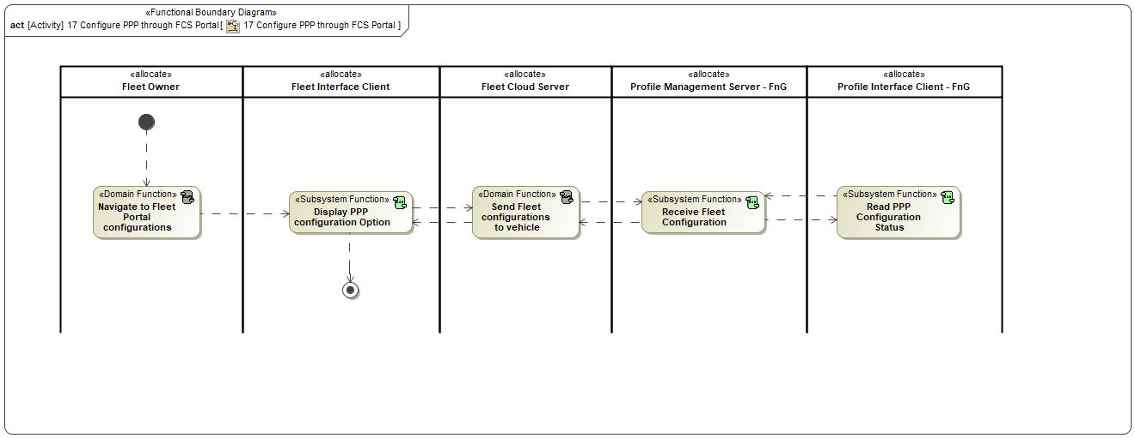

Figure 2: Activity Diagram of -556409490.jpg “17 Configure PPP through FCS Portal” calling 873751927.jpg “Read PPP Configuration Status”

### Function Interfaces

#### Logical Inputs

No Logical Inputs specified.

#### Logical Outputs

No Logical Outputs specified.

#### Logical Parameters

*Not supported by MagicDraw report generation.*

### Function Modeling

#### Use Cases

*Not supported by MagicDraw report generation.*

#### State Charts / Activity Diagrams / Sequence Diagrams / Decision Tables

No diagrams internal to function specified.

### Function Requirements

#### Functional Requirements

##### Normal Operation

REQ-460554/A Read PPP Configuration Status

The Profile Interface Client shall be able to read the PPP configuration status from the Profile Management Server.

|  |  |  |  |  |  |  |  |
| --- | --- | --- | --- | --- | --- | --- | --- |
| Requirement ID: REQ-460554/A | | | | | | | |
| **Rationale** |  | | | | | | |
| **Acceptance Criteria** |  | | | | | | |
| **Notes** |  | | | | | | |
| **Source** |  | | | | | **Owner** |  |
| **Source Req.** |  | | | | | **V&V Method** |  |
| **Type** |  | | | **Priority** |  | **Status** |  |
| [Req. Template](http://wiki.ford.com/display/RequirementsEngineering/Requirements+Attributes) Version | | 6.0 | End of Requirement | | | | |

REQ-460555/A Alter HMI flow based on Profile Management Server Configuration

If the Profile Interface Client reads the Profile Management Server PPP configuration status = OFF, then the Profile Interface Client shall be able to alter the profile creation flow to remove the following screens:

- FordPass Login screen

|  |  |  |  |  |  |  |  |
| --- | --- | --- | --- | --- | --- | --- | --- |
| Requirement ID: REQ-460555/A | | | | | | | |
| **Rationale** |  | | | | | | |
| **Acceptance Criteria** |  | | | | | | |
| **Notes** |  | | | | | | |
| **Source** |  | | | | | **Owner** |  |
| **Source Req.** |  | | | | | **V&V Method** |  |
| **Type** |  | | | **Priority** |  | **Status** |  |
| [Req. Template](http://wiki.ford.com/display/RequirementsEngineering/Requirements+Attributes) Version | | 6.0 | End of Requirement | | | | |

REQ-460556/A Unlink Portable Profiles from Account if Configuration Status = OFF

If there are pre-existing portable profiles linked to Ford Accounts and the Profile Interface Client reads the configuration status = OFF, then the Profile Interface Client shall request to unlink the profiles from the Ford Account for each linked profile.

|  |  |  |  |  |  |  |  |
| --- | --- | --- | --- | --- | --- | --- | --- |
| Requirement ID: REQ-460556/A | | | | | | | |
| **Rationale** |  | | | | | | |
| **Acceptance Criteria** |  | | | | | | |
| **Notes** |  | | | | | | |
| **Source** |  | | | | | **Owner** |  |
| **Source Req.** |  | | | | | **V&V Method** |  |
| **Type** |  | | | **Priority** |  | **Status** |  |
| [Req. Template](http://wiki.ford.com/display/RequirementsEngineering/Requirements+Attributes) Version | | 6.0 | End of Requirement | | | | |

##### Error Handling

No Error Handling Requirements specified.

#### Non-Functional Requirements

No Non-Functional Requirements specified.

#### Functional Safety Requirements

No Functional Safety Requirements specified.

##### ASIL Decomposition of Functional Safety Requirements

No Functional Safety Requirements with ASIL Decompositions specified.

#### Other Requirements

##### Design Requirements

No Design Requirements specified.

## 873751927.jpg Request New Profile Creation

### Function Overview

#### Description

Function is allocated to:

* 914643172.jpg Profile Interface Client - FnG <<Logical>>

No description provided for this function.

#### Variants

*Not supported by MagicDraw report generation.*

#### Input Requirements

*Not supported by MagicDraw report generation.*

#### Assumptions

No assumptions specified for this function.

#### References

##### Ford Documents

List here all Ford internal documents, which are directly related to the feature.

| **Reference** | **Title** | **Doc. ID** | **Revision** |
| --- | --- | --- | --- |
|  |  |  |  |

Table 5: Ford internal Documents *(not specified in model)*

##### External Documents and Publications

The list of external documents could include books, reports and online sources.

| **Reference** | **Document / Publication** |
| --- | --- |
|  |  |

Table 7: External documents and publications *(not specified in model)*

#### Glossary

See Appendix for Definitions and Abbreviations.

### Function Scope

The 873751927.jpg **– “Request New Profile Creation”** function is called by the following functions:

* -556409490.jpg – “1 Link New Vehicle Profile w/ FP Account”



Figure 2: Activity Diagram of -556409490.jpg “1 Link New Vehicle Profile w/ FP Account” calling 873751927.jpg “Request New Profile Creation”

### Function Interfaces

#### Logical Inputs

|  |  |
| --- | --- |
| **Signal Name** | **Description** |
| input  Type:  -1935932666.jpg pppStoreProfileData_Res | Signal Description:  Response to pppStoreProfileData_Rq indicating a Success or Failure.  Received from:   * -1849991780.jpg Collect Profile Settings |

#### Logical Outputs

|  |  |
| --- | --- |
| **Signal Name** | **Description** |
| output  Type:  -1991559816.jpg pppStoreProfileData_Rq | Signal Description:  Signal to request Profile Management Server to create and collect a new profile.  Sent to:   * -1849991780.jpg Collect Profile Settings |

#### Logical Parameters

*Not supported by MagicDraw report generation.*

### Function Modeling

#### Use Cases

*Not supported by MagicDraw report generation.*

#### State Charts / Activity Diagrams / Sequence Diagrams / Decision Tables

No diagrams internal to function specified.

### Function Requirements

#### Functional Requirements

##### Normal Operation

REQ-460557/A Send pppStoreProfileData - Profile Creation

When there is no profile imported during a profile creation and profile creation is completed, the Profile Interface Client shall send pppStoreProfileData to the Profile Management Server containing the profile name and pers index received in the profile creation.

|  |  |  |  |  |  |  |  |
| --- | --- | --- | --- | --- | --- | --- | --- |
| Requirement ID: REQ-460557/A | | | | | | | |
| **Rationale** |  | | | | | | |
| **Acceptance Criteria** |  | | | | | | |
| **Notes** |  | | | | | | |
| **Source** |  | | | | | **Owner** |  |
| **Source Req.** |  | | | | | **V&V Method** |  |
| **Type** |  | | | **Priority** |  | **Status** |  |
| [Req. Template](http://wiki.ford.com/display/RequirementsEngineering/Requirements+Attributes) Version | | 6.0 | End of Requirement | | | | |

##### Error Handling

REQ-460558/A Receiving pppStoreProfileData = FAILED

If the Profile Interface Client receives pppStoreProfileData(ResponseCode=Failed, ErrorCode), it shall perform the following:

- INVALID_INDEX: Request user to select seat button again if this cannot be fixed internally

- INCOMPATIBLE_API: Display an error notification requiring service

- COMMAND_NOT_SUPPORTED: Display an error notification requiring service

- COMMAND_NOT_PERMITTED: Nothing - future use

- COMMAND_TIMEOUT: Display an error notification with option to Retry or Cancel. Cancel shall leave Setup Wizard

- COMMAND_QUEUE_FULL: Display an error notification to try again later with option to Retry or Cancel

- DENIED_RATE_LIMIT_EXCEEDED: Display an error notification to try again later with option to Retry or Cancel

- UNKOWN_ERROR: Display an error notification to try again later with option to Retry or Cancel

|  |  |  |  |  |  |  |  |
| --- | --- | --- | --- | --- | --- | --- | --- |
| Requirement ID: REQ-460558/A | | | | | | | |
| **Rationale** |  | | | | | | |
| **Acceptance Criteria** |  | | | | | | |
| **Notes** |  | | | | | | |
| **Source** |  | | | | | **Owner** |  |
| **Source Req.** |  | | | | | **V&V Method** |  |
| **Type** |  | | | **Priority** |  | **Status** |  |
| [Req. Template](http://wiki.ford.com/display/RequirementsEngineering/Requirements+Attributes) Version | | 6.0 | End of Requirement | | | | |

#### Non-Functional Requirements

No Non-Functional Requirements specified.

#### Functional Safety Requirements

No Functional Safety Requirements specified.

##### ASIL Decomposition of Functional Safety Requirements

No Functional Safety Requirements with ASIL Decompositions specified.

#### Other Requirements

##### Design Requirements

No Design Requirements specified.

## -836794363.jpg Request New Passenger Profile Creation

### Function Overview

#### Description

Function is allocated to:

* 914643172.jpg Profile Interface Client - FnG <<Logical>>

No description provided for this function.

#### Variants

*Not supported by MagicDraw report generation.*

#### Input Requirements

*Not supported by MagicDraw report generation.*

#### Assumptions

No assumptions specified for this function.

#### References

##### Ford Documents

List here all Ford internal documents, which are directly related to the feature.

| **Reference** | **Title** | **Doc. ID** | **Revision** |
| --- | --- | --- | --- |
|  |  |  |  |

Table 5: Ford internal Documents *(not specified in model)*

##### External Documents and Publications

The list of external documents could include books, reports and online sources.

| **Reference** | **Document / Publication** |
| --- | --- |
|  |  |

Table 7: External documents and publications *(not specified in model)*

#### Glossary

See Appendix for Definitions and Abbreviations.

### Function Scope

The -836794363.jpg **– “Request New Passenger Profile Creation”** function is called by the following functions:

* -739592470.jpg – “Create Passenger Profile via HMI - First Entry”

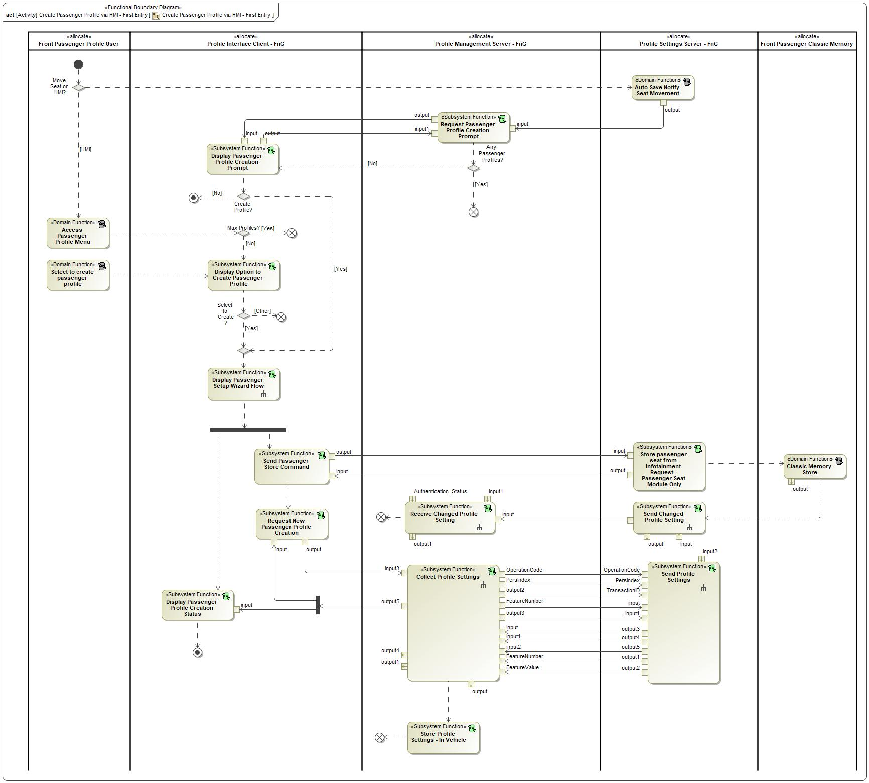

Figure 2: Activity Diagram of -739592470.jpg “Create Passenger Profile via HMI - First Entry” calling 1525459522.jpg “Request New Passenger Profile Creation”

### Function Interfaces

#### Logical Inputs

|  |  |
| --- | --- |
| **Signal Name** | **Description** |
| input  Type:  1248612702.jpg pppStoreProfileData_Res | Signal Description:  Response to pppStoreProfileData_Rq indicating a Success or Failure.  Received from:   * 1525459522.jpg Collect Profile Settings |

#### Logical Outputs

|  |  |  |
| --- | --- | --- |
| **Signal Name** | **Description** | |
| output  Type:  1248612702.jpg pppStoreProfileData_Rq | Signal Description:  Signal to request Profile Management Server to create and collect a new profile.  Sent to:   * 1525459522.jpg Collect Profile Settings | |



#### Logical Parameters

*Not supported by MagicDraw report generation.*

### Function Modeling

#### Use Cases

*Not supported by MagicDraw report generation.*

#### State Charts / Activity Diagrams / Sequence Diagrams / Decision Tables

No diagrams internal to function specified.

### Function Requirements

#### Functional Requirements

##### Normal Operation

REQ-462350/A

|  |  |  |  |  |  |  |  |
| --- | --- | --- | --- | --- | --- | --- | --- |
|  | | | | | | | |
|  |  | | | | | | |
|  |  | | | | | | |
|  |  | | | | | | |
|  |  | | | | |  |  |
|  |  | | | | |  |  |
|  |  | | |  |  |  |  |
|  | |  |  | | | | |

REQ-462351/A

|  |  |  |  |  |  |  |  |
| --- | --- | --- | --- | --- | --- | --- | --- |
|  | | | | | | | |
|  |  | | | | | | |
|  |  | | | | | | |
|  |  | | | | | | |
|  |  | | | | |  |  |
|  |  | | | | |  |  |
|  |  | | |  |  |  |  |
|  | |  |  | | | | |

##### Error Handling

No Error Handling Requirements specified.

#### Non-Functional Requirements

No Non-Functional Requirements specified.

#### Functional Safety Requirements

No Functional Safety Requirements specified.

##### ASIL Decomposition of Functional Safety Requirements

No Functional Safety Requirements with ASIL Decompositions specified.

#### Other Requirements

##### Design Requirements

No Design Requirements specified.

## 873751927.jpg Send Passenger Store Command

### Function Overview

#### Description

Function is allocated to:

* 1716959969.jpg Front Passenger Profiles <<Feature>>
* 914643172.jpg Profile Interface Client - FnG <<Logical>>

Function that requests the Passenger Classic Memory system to store the current seat position to the requested PersIndex.

#### Variants

*Not supported by MagicDraw report generation.*

#### Input Requirements

*Not supported by MagicDraw report generation.*

#### Assumptions

No assumptions specified for this function.

#### References

##### Ford Documents

List here all Ford internal documents, which are directly related to the feature.

| **Reference** | **Title** | **Doc. ID** | **Revision** |
| --- | --- | --- | --- |
|  |  |  |  |

Table 5: Ford internal Documents *(not specified in model)*

##### External Documents and Publications

The list of external documents could include books, reports and online sources.

| **Reference** | **Document / Publication** |
| --- | --- |
|  |  |

Table 7: External documents and publications *(not specified in model)*

#### Glossary

See Appendix for Definitions and Abbreviations.

### Function Scope

The 873751927.jpg **– “Send Passenger Store Command”** function is called by the following functions:

* -556409490.jpg – “Create Passenger Profile via HMI - First Entry”
* -556409490.jpg – “Manual Save Passenger Seat Position”



Figure 2: Activity Diagram of -556409490.jpg “Create Passenger Profile via HMI - First Entry” calling 873751927.jpg “Send Passenger Store Command”



Figure 2: Activity Diagram of -556409490.jpg “Manual Save Passenger Seat Position” calling 873751927.jpg “Send Passenger Store Command”

### Function Interfaces

#### Logical Inputs

|  |  |
| --- | --- |
| **Signal Name** | **Description** |
| input  Type:  -678216178.jpg InfotainmentPsngrPersStore_St | Signal Description:  The signal is used to inform the Profile Interface Client the status of a requested store event.  Received from:   * 873751927.jpg Store passenger seat from Infotainment Request - Passenger Seat Module Only |

#### Logical Outputs

|  |  |
| --- | --- |
| **Signal Name** | **Description** |
| output  Type:  -678216178.jpg InfotainmentPsngrPersStore_Rq | Signal Description:  The signal is used by the Profile Interface Client to request current passenger classic memory settings to be stored to the indicated personality profile.  Sent to:   * 873751927.jpg Store passenger seat from Infotainment Request - Passenger Seat Module Only |

#### Logical Parameters

*Not supported by MagicDraw report generation.*

### Function Modeling

#### Use Cases

*Not supported by MagicDraw report generation.*

#### State Charts / Activity Diagrams / Sequence Diagrams / Decision Tables

No diagrams internal to function specified.

### Function Requirements

#### Functional Requirements

##### Normal Operation











REQ-464837 Send request to store after Manual Save request

When the user presses the manual save button on the Profile Interface Client HMI, the Profile Interface Client shall send InfotainmentPsngrPersStore_Rq = PERS_1 to the Passenger Classic Memory System (Passenger Seat Module) to request a Passenger Seat store operation.

|  |  |  |  |  |  |  |  |
| --- | --- | --- | --- | --- | --- | --- | --- |
| Requirement ID: | | | | | | | |
| **Rationale** |  | | | | | | |
| **Acceptance Criteria** |  | | | | | | |
| **Notes** |  | | | | | | |
| **Source** |  | | | | | **Owner** |  |
| **Source Req.** |  | | | | | **V&V Method** |  |
| **Type** |  | | | **Priority** |  | **Status** |  |
| [Req. Template](http://wiki.ford.com/display/RequirementsEngineering/Requirements+Attributes) Version | | 6.0 | End of Requirement | | | | |

REQ-464838 Receiving InfotainmentPsngrPersStore_St - Passenger Manual Save

When the Profile Interface Client receives InfotainmentPsngrPersStore_St after sending InfotainmentPsngrPersStore_Rq for a manual save operation, the Profile Interface Client shall do the following based on the following received status:

- If COMPLETE, Profile Interface Client shall wait for feedback before displaying a confirmation prompt

- If InProgress, Profile Interface Client shall wait until COMPLETE status is received.

|  |  |  |  |  |  |  |  |
| --- | --- | --- | --- | --- | --- | --- | --- |
| Requirement ID: | | | | | | | |
| **Rationale** |  | | | | | | |
| **Acceptance Criteria** |  | | | | | | |
| **Notes** |  | | | | | | |
| **Source** |  | | | | | **Owner** |  |
| **Source Req.** |  | | | | | **V&V Method** |  |
| **Type** |  | | | **Priority** |  | **Status** |  |
| [Req. Template](http://wiki.ford.com/display/RequirementsEngineering/Requirements+Attributes) Version | | 6.0 | End of Requirement | | | | |

REQ-462370/A Send request to store after Passenger Profile Creation

When the user selects "Next" (or similar) on the Passenger Seat Configuration screen during Passenger Profile creation, the Profile Interface Client shall send InfotainmentPsngrPersStore_Rq = PERS_1 to the Passenger Classic Memory System (Passenger Seat Module) to request a Passenger Seat store operation.

|  |  |  |  |  |  |  |  |
| --- | --- | --- | --- | --- | --- | --- | --- |
| Requirement ID: REQ-462370/A | | | | | | | |
| **Rationale** |  | | | | | | |
| **Acceptance Criteria** |  | | | | | | |
| **Notes** |  | | | | | | |
| **Source** |  | | | | | **Owner** |  |
| **Source Req.** |  | | | | | **V&V Method** |  |
| **Type** |  | | | **Priority** |  | **Status** |  |
| [Req. Template](http://wiki.ford.com/display/RequirementsEngineering/Requirements+Attributes) Version | | 6.0 | End of Requirement | | | | |

REQ-462371/A Receiving InfotainmentPsngrPersStore_St - Passenger Profile Creation

When the Profile Interface Client receives InfotainmentPsngrPersStore_St after sending InfotainmentPsngrPersStore_Rq during passenger profile creation, the Profile Interface Client shall do the following based on the following received status:

- If COMPLETE, Profile Interface Client shall request to create a new passenger profile by sending pppStoreProfileData_Rq

- If InProgress, Profile Interface Client shall wait until COMPLETE status is received.

|  |  |  |  |  |  |  |  |
| --- | --- | --- | --- | --- | --- | --- | --- |
| Requirement ID: REQ-462371/A | | | | | | | |
| **Rationale** |  | | | | | | |
| **Acceptance Criteria** |  | | | | | | |
| **Notes** |  | | | | | | |
| **Source** |  | | | | | **Owner** |  |
| **Source Req.** |  | | | | | **V&V Method** |  |
| **Type** |  | | | **Priority** |  | **Status** |  |
| [Req. Template](http://wiki.ford.com/display/RequirementsEngineering/Requirements+Attributes) Version | | 6.0 | End of Requirement | | | | |

REQ-462372/A Return to Null State - InfotainmentPsngrPersStore_Rq

When updating on an event, InfotainmentPsngrPersStore_Rq shall hold its encoding values for a period of time defined by T_ReturnToNull and then shall transit back to Null.

|  |  |  |  |  |  |  |  |
| --- | --- | --- | --- | --- | --- | --- | --- |
| Requirement ID: REQ-462372/A | | | | | | | |
| **Rationale** |  | | | | | | |
| **Acceptance Criteria** |  | | | | | | |
| **Notes** |  | | | | | | |
| **Source** |  | | | | | **Owner** |  |
| **Source Req.** |  | | | | | **V&V Method** |  |
| **Type** |  | | | **Priority** |  | **Status** |  |
| [Req. Template](http://wiki.ford.com/display/RequirementsEngineering/Requirements+Attributes) Version | | 6.0 | End of Requirement | | | | |

##### Error Handling

No Error Handling Requirements specified.

#### Non-Functional Requirements

No Non-Functional Requirements specified.

#### Functional Safety Requirements

No Functional Safety Requirements specified.

##### ASIL Decomposition of Functional Safety Requirements

No Functional Safety Requirements with ASIL Decompositions specified.

#### Other Requirements

##### Design Requirements

No Design Requirements specified.

## 873751927.jpg Send Passenger Recall Request

### Function Overview

#### Description

Function is allocated to:

* 1716959969.jpg Front Passenger Profiles <<Feature>>
* 914643172.jpg Profile Interface Client - FnG <<Logical>>

Profile Interface Client requests the Profile Management Server to initial a passenger profile recall.

#### Variants

*Not supported by MagicDraw report generation.*

#### Input Requirements

*Not supported by MagicDraw report generation.*

#### Assumptions

No assumptions specified for this function.

#### References

##### Ford Documents

List here all Ford internal documents, which are directly related to the feature.

| **Reference** | **Title** | **Doc. ID** | **Revision** |
| --- | --- | --- | --- |
|  |  |  |  |

Table 5: Ford internal Documents *(not specified in model)*

##### External Documents and Publications

The list of external documents could include books, reports and online sources.

| **Reference** | **Document / Publication** |
| --- | --- |
|  |  |

Table 7: External documents and publications *(not specified in model)*

#### Glossary

See Appendix for Definitions and Abbreviations.

### Function Scope

The 873751927.jpg **– “Send Recall Request”** function is called by the following functions:

* -556409490.jpg – “Recall Passenger Profile”
* -556409490.jpg – “Reload Passenger Seat Position”



Figure 2: Activity Diagram of -556409490.jpg “Recall Passenger Profile” calling 873751927.jpg “Send Recall Request”



Figure 2: Activity Diagram of -556409490.jpg “Reload Passenger Seat Position” calling 873751927.jpg “Send Recall Request”

### Function Interfaces

#### Logical Inputs

No Logical Inputs specified.

#### Logical Outputs

|  |  |
| --- | --- |
| **Signal Name** | **Description** |
| output  Type:  -678216178.jpg PsngrRecall_Rq | Signal Description:  Passenger Recall request from the Profile Interface Client to the Profile Management Server  Sent to:   * 873751927.jpg Send Passenger Profile Activation * 873751927.jpg Push Profile Settings |

#### Logical Parameters

*Not supported by MagicDraw report generation.*

### Function Modeling

#### Use Cases

*Not supported by MagicDraw report generation.*

#### State Charts / Activity Diagrams / Sequence Diagrams / Decision Tables

No diagrams internal to function specified.

### Function Requirements

#### Functional Requirements

##### Normal Operation

REQ-462375/A Send Passenger Profile Recall Request - Reload settings

When the User selects to Reload a Passenger Profile seat position, the Profile Interface Client shall send a Recall Passenger Profile request to the Profile Management Server indicating that only an ACTIVATE operation is required.

|  |  |  |  |  |  |  |  |
| --- | --- | --- | --- | --- | --- | --- | --- |
| Requirement ID: | | | | | | | |
| **Rationale** |  | | | | | | |
| **Acceptance Criteria** |  | | | | | | |
| **Notes** |  | | | | | | |
| **Source** |  | | | | | **Owner** |  |
| **Source Req.** |  | | | | | **V&V Method** |  |
| **Type** |  | | | **Priority** |  | **Status** |  |
| [Req. Template](http://wiki.ford.com/display/RequirementsEngineering/Requirements+Attributes) Version | | 6.0 | End of Requirement | | | | |

REQ-462374/A HMI indicator during Passenger Profile recall request

After a Passenger Profile recall is initiated, the Profile Interface Client shall display an indicator that a Passenger Profile recall is in progress. The indicator shall disappear once the recall is complete.

|  |  |  |  |  |  |  |  |
| --- | --- | --- | --- | --- | --- | --- | --- |
| Requirement ID: | | | | | | | |
| **Rationale** |  | | | | | | |
| **Acceptance Criteria** |  | | | | | | |
| **Notes** |  | | | | | | |
| **Source** |  | | | | | **Owner** |  |
| **Source Req.** |  | | | | | **V&V Method** |  |
| **Type** |  | | | **Priority** |  | **Status** |  |
| [Req. Template](http://wiki.ford.com/display/RequirementsEngineering/Requirements+Attributes) Version | | 6.0 | End of Requirement | | | | |

REQ-462373/A Send Passenger Profile Recall Request to Profile Management Server

When the user recalls a Passenger Profile, the Profile Interface Client shall send a Recall request to the Profile Management Server indicating that a Full recall of the selected passenger profile (push settings and then activate) is required.

|  |  |  |  |  |  |  |  |
| --- | --- | --- | --- | --- | --- | --- | --- |
| Requirement ID: | | | | | | | |
| **Rationale** |  | | | | | | |
| **Acceptance Criteria** |  | | | | | | |
| **Notes** |  | | | | | | |
| **Source** |  | | | | | **Owner** |  |
| **Source Req.** |  | | | | | **V&V Method** |  |
| **Type** |  | | | **Priority** |  | **Status** |  |
| [Req. Template](http://wiki.ford.com/display/RequirementsEngineering/Requirements+Attributes) Version | | 6.0 | End of Requirement | | | | |

##### Error Handling

No Error Handling Requirements specified.

#### Non-Functional Requirements

No Non-Functional Requirements specified.

#### Functional Safety Requirements

No Functional Safety Requirements specified.

##### ASIL Decomposition of Functional Safety Requirements

No Functional Safety Requirements with ASIL Decompositions specified.

#### Other Requirements

##### Design Requirements

No Design Requirements specified.

## 873751927.jpg Unlink Ford Account

### Function Overview

#### Description

Function is allocated to:

* 938416679.jpg Display Option to Unlink FP Account - APIM <<Logical>>
* 914643172.jpg Profile Interface Client - FnG <<Logical>>

HMI function that provides the capability for the user to link their FP account to any pre-existing vehicle profiles.

#### Variants

*Not supported by MagicDraw report generation.*

#### Input Requirements

*Not supported by MagicDraw report generation.*

#### Assumptions

No assumptions specified for this function.

#### References

##### Ford Documents

List here all Ford internal documents, which are directly related to the feature.

| **Reference** | **Title** | **Doc. ID** | **Revision** |
| --- | --- | --- | --- |
|  |  |  |  |

Table 5: Ford internal Documents *(not specified in model)*

##### External Documents and Publications

The list of external documents could include books, reports and online sources.

| **Reference** | **Document / Publication** |
| --- | --- |
|  |  |

Table 7: External documents and publications *(not specified in model)*

#### Glossary

See Appendix for Definitions and Abbreviations.

### Function Scope

The 873751927.jpg **– “Unlink Ford Account”** function is called by the following functions:

* -556409490.jpg – “6 Unlink Vehicle Profile From FP Account”

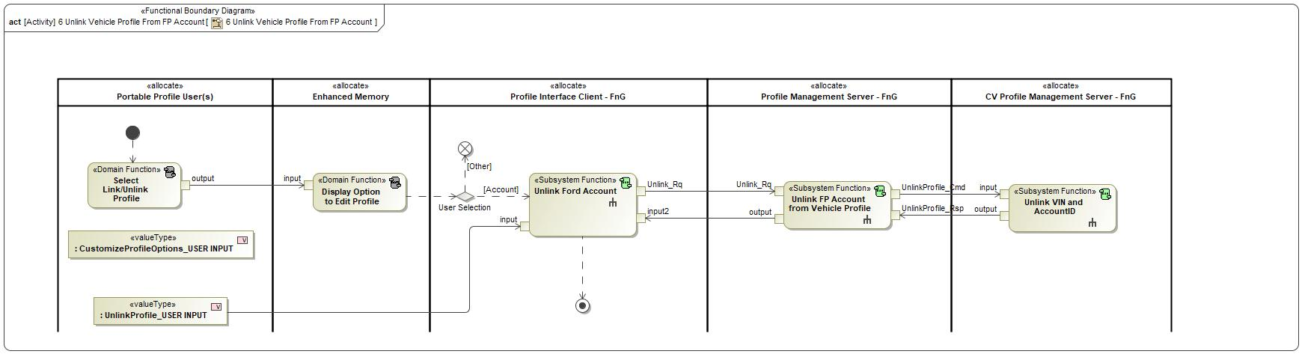

Figure 2: Activity Diagram of -556409490.jpg “6 Unlink Vehicle Profile From FP Account” calling 873751927.jpg “Unlink Ford Account”

### Function Interfaces

#### Logical Inputs

|  |  |
| --- | --- |
| **Signal Name** | **Description** |
| input  Type:  1436794828.jpg UnlinkProfile_USER INPUT |  |
| input2  Type:  1436794828.jpg Unlink_Rsp | Signal Description:  Response to the Unlink_Rq indicating a Success or Failure when unlinking a profile from a Ford Account.  Received from:   * -836794363.jpg Unlink FP Account from Vehicle Profile |

#### Logical Outputs

|  |  |
| --- | --- |
| **Signal Name** | **Description** |
| Unlink_Rq  Type:  1436794828.jpg Unlink_Rq | Signal Description:  Request from the Profile Interface Client to the Profile Management Server to unlink a profile from its linked Ford account.  Sent to:   * -836794363.jpg Unlink FP Account from Vehicle Profile |

#### Logical Parameters

*Not supported by MagicDraw report generation.*

### Function Modeling

#### Use Cases

*Not supported by MagicDraw report generation.*

#### State Charts / Activity Diagrams / Sequence Diagrams / Decision Tables

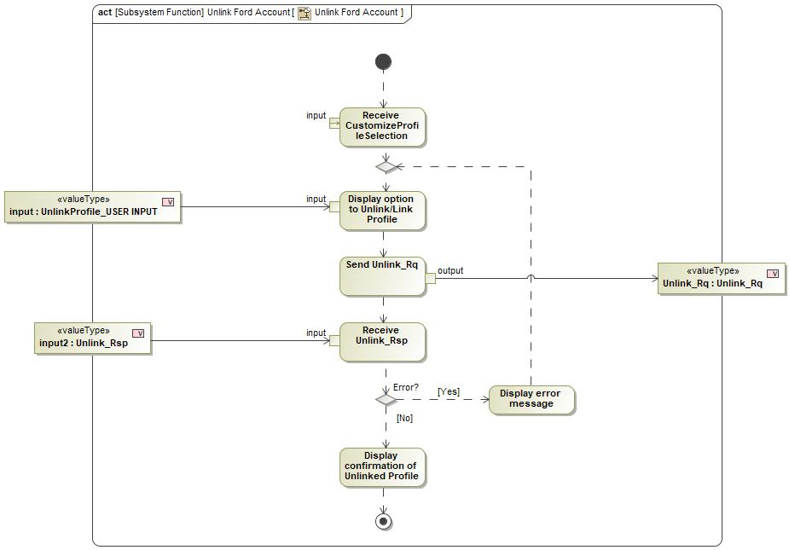

Figure 3: Unlink Ford Account

### Function Requirements

#### Functional Requirements

##### Normal Operation

REQ-460559/A Unlinking a Ford Account from vehicle profile

When a user selects the Ford Account Link option on the Customize Profile Screen for a profile that is linked to a Ford Account, the Profile Interface Client shall provide an option to unlink the profile from the Ford Account.

|  |  |  |  |  |  |  |  |
| --- | --- | --- | --- | --- | --- | --- | --- |
| Requirement ID: REQ-460559/A | | | | | | | |
| **Rationale** |  | | | | | | |
| **Acceptance Criteria** |  | | | | | | |
| **Notes** |  | | | | | | |
| **Source** |  | | | | | **Owner** |  |
| **Source Req.** |  | | | | | **V&V Method** |  |
| **Type** |  | | | **Priority** |  | **Status** |  |
| [Req. Template](http://wiki.ford.com/display/RequirementsEngineering/Requirements+Attributes) Version | | 6.0 | End of Requirement | | | | |

REQ-460560/A Sending Unlink_Rq

When a user selects to unlink their profile from the linked Ford Account, the Profile Interface Client shall send Unlink_Rq to the Profile Management Server.

|  |  |  |  |  |  |  |  |
| --- | --- | --- | --- | --- | --- | --- | --- |
| Requirement ID: REQ-460560/A | | | | | | | |
| **Rationale** |  | | | | | | |
| **Acceptance Criteria** |  | | | | | | |
| **Notes** |  | | | | | | |
| **Source** |  | | | | | **Owner** |  |
| **Source Req.** |  | | | | | **V&V Method** |  |
| **Type** |  | | | **Priority** |  | **Status** |  |
| [Req. Template](http://wiki.ford.com/display/RequirementsEngineering/Requirements+Attributes) Version | | 6.0 | End of Requirement | | | | |

REQ-460561/A Receiving Unlink_Rsp = SUCCESS

When the Profile Interface Client receives Unlink_Rsp = SUCCESS, the Profile Interface Client shall display a confirmation message on the HMI.

|  |  |  |  |  |  |  |  |
| --- | --- | --- | --- | --- | --- | --- | --- |
| Requirement ID: REQ-460561/A | | | | | | | |
| **Rationale** |  | | | | | | |
| **Acceptance Criteria** |  | | | | | | |
| **Notes** |  | | | | | | |
| **Source** |  | | | | | **Owner** |  |
| **Source Req.** |  | | | | | **V&V Method** |  |
| **Type** |  | | | **Priority** |  | **Status** |  |
| [Req. Template](http://wiki.ford.com/display/RequirementsEngineering/Requirements+Attributes) Version | | 6.0 | End of Requirement | | | | |

##### Error Handling

REQ-460562/A Receiving Unlink_Rsp = FAIL

If the Profile Interface Client receives Unlink_Rsp = FAIL, the Profile Interface Client shall display an error message on the HMI and return to the Option to Unlink Ford Account screen.

|  |  |  |  |  |  |  |  |
| --- | --- | --- | --- | --- | --- | --- | --- |
| Requirement ID: REQ-460562/A | | | | | | | |
| **Rationale** |  | | | | | | |
| **Acceptance Criteria** |  | | | | | | |
| **Notes** |  | | | | | | |
| **Source** |  | | | | | **Owner** |  |
| **Source Req.** |  | | | | | **V&V Method** |  |
| **Type** |  | | | **Priority** |  | **Status** |  |
| [Req. Template](http://wiki.ford.com/display/RequirementsEngineering/Requirements+Attributes) Version | | 6.0 | End of Requirement | | | | |

#### Non-Functional Requirements

No Non-Functional Requirements specified.

#### Functional Safety Requirements

No Functional Safety Requirements specified.

##### ASIL Decomposition of Functional Safety Requirements

No Functional Safety Requirements with ASIL Decompositions specified.

#### Other Requirements

##### Design Requirements

No Design Requirements specified.

## -836794363.jpg Update and Store Wizard Settings

### Function Overview

#### Description

Function is allocated to:

* 914643172.jpg Profile Interface Client - FnG <<Logical>>

No description provided for this function.

#### Variants

*Not supported by MagicDraw report generation.*

#### Input Requirements

*Not supported by MagicDraw report generation.*

#### Assumptions

No assumptions specified for this function.

#### References

##### Ford Documents

List here all Ford internal documents, which are directly related to the feature.

| **Reference** | **Title** | **Doc. ID** | **Revision** |
| --- | --- | --- | --- |
|  |  |  |  |

Table 5: Ford internal Documents *(not specified in model)*

##### External Documents and Publications

The list of external documents could include books, reports and online sources.

| **Reference** | **Document / Publication** |
| --- | --- |
|  |  |

Table 7: External documents and publications *(not specified in model)*

#### Glossary

See Appendix for Definitions and Abbreviations.

### Function Scope

The -836794363.jpg **– “Update and Store Wizard Settings”** function is called by the following functions:

* -556409490.jpg – “1 Link New Vehicle Profile w/ FP Account”



Figure 2: Activity Diagram of -556409490.jpg “1 Link New Vehicle Profile w/ FP Account” calling -836794363.jpg “Update and Store Wizard Settings”

### Function Interfaces

#### Logical Inputs

|  |  |
| --- | --- |
| **Signal Name** | **Description** |
| input  Type:  -197013141.jpg pppUpdateWizardSettings_Rq | Signal Description:  Sends setup wizard specific settings during profile creation. Also, indicates if a profile was imported or not.  Received from:   * -1896710573.jpg Update Wizard Settings |

#### Logical Outputs

|  |  |
| --- | --- |
| **Signal Name** | **Description** |
| output  Type:  -197013141.jpg pppUpdateWizardSettings_Res | Signal Description:  Response to the pppUpdateWizardSettings_Rq indicating Success or Fail.  Sent to:   * -1896710573.jpg Update Wizard Settings |

#### Logical Parameters

*Not supported by MagicDraw report generation.*

### Function Modeling

#### Use Cases

*Not supported by MagicDraw report generation.*

#### State Charts / Activity Diagrams / Sequence Diagrams / Decision Tables

No diagrams internal to function specified.

### Function Requirements

#### Functional Requirements

##### Normal Operation

REQ-460563/A Receive pppUpdateWizardSettings

After receiving pppProfileID_Res = OK from the Profile Management Server, the Profile Interface Client shall wait for pppUpdateWizardSettings to indicate if a profile was imported or not.

|  |  |  |  |  |  |  |  |
| --- | --- | --- | --- | --- | --- | --- | --- |
| Requirement ID: REQ-460563/A | | | | | | | |
| **Rationale** |  | | | | | | |
| **Acceptance Criteria** |  | | | | | | |
| **Notes** |  | | | | | | |
| **Source** |  | | | | | **Owner** |  |
| **Source Req.** |  | | | | | **V&V Method** |  |
| **Type** |  | | | **Priority** |  | **Status** |  |
| [Req. Template](http://wiki.ford.com/display/RequirementsEngineering/Requirements+Attributes) Version | | 6.0 | End of Requirement | | | | |

REQ-460564/A pppUpdateWizardSettings = No Profile

If pppUpdateWizardSettings indicates that there was no profile imported, the Profile Interface Client shall continue setup wizard and include screens to collect profile name and profile avatar and any other setup wizard settings.

|  |  |  |  |  |  |  |  |
| --- | --- | --- | --- | --- | --- | --- | --- |
| Requirement ID: REQ-460564/A | | | | | | | |
| **Rationale** |  | | | | | | |
| **Acceptance Criteria** |  | | | | | | |
| **Notes** |  | | | | | | |
| **Source** |  | | | | | **Owner** |  |
| **Source Req.** |  | | | | | **V&V Method** |  |
| **Type** |  | | | **Priority** |  | **Status** |  |
| [Req. Template](http://wiki.ford.com/display/RequirementsEngineering/Requirements+Attributes) Version | | 6.0 | End of Requirement | | | | |

REQ-460565/A pppUpdateWizardSettings contains profile settings

If pppUpdateWizardSettings indicates that there was a profile imported and contains profile settings, the Profile Interface Client shall receive and store the settings in pppUpdateWizardSettings and skip the profile name and avatar screens.

|  |  |  |  |  |  |  |  |
| --- | --- | --- | --- | --- | --- | --- | --- |
| Requirement ID: REQ-460565/A | | | | | | | |
| **Rationale** |  | | | | | | |
| **Acceptance Criteria** |  | | | | | | |
| **Notes** |  | | | | | | |
| **Source** |  | | | | | **Owner** |  |
| **Source Req.** |  | | | | | **V&V Method** |  |
| **Type** |  | | | **Priority** |  | **Status** |  |
| [Req. Template](http://wiki.ford.com/display/RequirementsEngineering/Requirements+Attributes) Version | | 6.0 | End of Requirement | | | | |

REQ-460566/A Send response to pppUpdateWizardSettings

The Profile Interface Client shall send the following responses after receiving pppUpdateWizardSettings:

- Response = SUCCESS if Profile Interface Client able to receive and read data

- Response = FAILED if Profile Interface Client was unable to read data

|  |  |  |  |  |  |  |  |
| --- | --- | --- | --- | --- | --- | --- | --- |
| Requirement ID: REQ-460566/A | | | | | | | |
| **Rationale** |  | | | | | | |
| **Acceptance Criteria** |  | | | | | | |
| **Notes** |  | | | | | | |
| **Source** |  | | | | | **Owner** |  |
| **Source Req.** |  | | | | | **V&V Method** |  |
| **Type** |  | | | **Priority** |  | **Status** |  |
| [Req. Template](http://wiki.ford.com/display/RequirementsEngineering/Requirements+Attributes) Version | | 6.0 | End of Requirement | | | | |

##### Error Handling

No Error Handling Requirements specified.

#### Non-Functional Requirements

No Non-Functional Requirements specified.

#### Functional Safety Requirements

No Functional Safety Requirements specified.

##### ASIL Decomposition of Functional Safety Requirements

No Functional Safety Requirements with ASIL Decompositions specified.

#### Other Requirements

##### Design Requirements

No Design Requirements specified.

# Open Concerns

**#Hint:** The following list presents open concerns, which have to be discussed or clarified over the course of the on-going requirements engineering.

| ID | Concern Description | e-Tracker / Reference | Responsible | Status | Solution |
| --- | --- | --- | --- | --- | --- |
| 1 |  |  |  |  |  |

Table 8: Open Concerns *(Not supported by MagicDraw report generation.)*

# Revision History

**#Hint:** A new version number is assigned to a document with a given revision each time it is checked in to Team Center (TCSE). After release of a revision, the document cannot be edited and no new versions can be created on that revision. When updating the document after that, a new revision has to be created and new versions on that revision will be created upon checking in.

|  |  |  |  |  |
| --- | --- | --- | --- | --- |
| Version | Rev. | Date | Description | Responsible |
| 1 | 0 | 2021-03-10 | Initial version | Jbauer50 |
| 1 | 1 | 2021-06-04 | * Added encoding values to logical signals * Removed the following functions to consolidate with other functions: * Display Confirmation of Updated Profile * Display Error Messages * Display Welcome Screen with ID Method | Jbauer50 |
| 1 | 2 | 2021-08-20 | * Added Fleet function – Read PPP Configuration Status * For new function added requirements, interfaces, activity diagram. | Jbauer50 |
| 1 | 3 | 2021-10-08 | * Added the following Passenger Profile functions: “Display Active Front Passenger Profile”, “Display Option to Create Passenger Profile”, “Display Passenger Edit Profile Menu”, “Display Passenger Profile Creation Prompt”, “Display Passenger Profile Creation Status”, “Display Passenger Profiles Menu”, “Display Passenger Setup Wizard Flow”, “Send Passenger Store Command”, “Send Recall Request”. | Jbauer50 |
| 1 | 4 | 2021-11-03 | * Added requirement numbers for the requirements * Revised following requirements: REQ-462311, REQ-462327, REQ-462323, REQ-462373 * Removed following functions: “Display Passenger Edit Profile Menu”, “Link Primary Passenger”, * Consolidated “Setup Primary Authentication” and “Setup Secondary Authentication – Passcode” into one function, “Primary Authentication”. * Added following functions: “Request New Passenger Profile Creation” * Added the following requirements: REQ-464837, REQ-464838 | Jbauer50 |

## Template Revisions

*#Important: Do not change this section*

|  |  |  |  |  |
| --- | --- | --- | --- | --- |
| Version | Rev. | Date | Description | Responsible |
| *1* | *0* | *2016-02-26* | *Initial version, derived from FDS* | *Jbaden1* |
| *1* | *1* | *2016-02-26* | *Word properties corrected* | *Jbaden1* |
| *1* | *2* | *2016-03-10* | *Clean up of document meta data (Word properties)* | *Jbaden1* |
| *1* | *3* | *2016-03-22* | * *Footer formatting corrected (Issue 19)* * *“Constraints” chapter renamed to “Input Requirements” (Issue 20)* | *Jbaden1* |
| *1* | *4* | *2016-04-20* | * *Broken Wiki links repaired* | *Jbaden1* |
| *2* | *0* | *2016-06-10* | * *Document metadata adapted. Prepared for new macros* * *DTC table removed* * *HMI function added as a chapter (details still to be refined)* * *Signal / Parameter IDs column deleted interface tables* | *Jbaden1* |
| *2* | *1* | *2016-07-14* | * *Converted to SysML diagrams* * *HMI section further elaborated* * *Template version added to footer* * *Dedicated Startup / Shutdown sections removed (only hints added)* * *Data Dictionary reworked and Signal / Parameter IDs column re-introduced* | *Jbaden1* |
| *2* | *2* | *2016-12-07* | * *Minor formatting changes* | *Jbaden1* |
| *3* |  |  | *Skipped to synchronize with Specification_Macros.dotm* |  |
| *4* |  |
| *5* | *0* | *2017-01-13* | * *Meta data updated for specification macros, version 3.1* * *SW Unit chapter removed for the time being* * *Green boxes added for user hints* | *Jbaden1* |
| *5* | *1* | *2017-01-18* | * *Some additional hints.* * *Hyperlinks highlighted in hints* | *Jbaden1* |
| *6* | *0* | *2017-04-28* | * *Editorial change. Hints added to chapter 4.1.4* * *Chapter “Traceability Matrix” removed* | *Jbaden1* |
| *6* | *0* | *2018-04-28* | * *CR69/63: New chapters added for Functional Safety (FTTI and Technical Safety Requirements)* * *CR53: New coversheet + additional meta-data* * *CR76: merge sections for configuration and for calibration parameters into one on Function Level* | *Jbaden1* |
| *6* | *0* | *2018-08-06* | * *CR66: Fix version numbering in footer of Function Spec* | *Jbaden1* |
| *6* | *0* | *2018-09-28* | * *Broken links to RE Wiki repaired* | *Jbaden1* |
| *6* | *0* | *2018-10-31* | * *Minor corrections on cover sheet and in footer to be more GIS compliant and VSEM aligned* * *“Overview” and “Description” exchanged in headings (following common sense)* | *Jbaden1* |
| *6* | *0* | *2018-11-12* | * *Explanatory text in Variants” section revised* * *Functional Safety modifications as agreed with FuSa core team (Baseline: November 2018 Dearborn On-Site)* | *Jbaden1* |
| *M* |  | *2019-04-02* | * *Initial version of SysML report template* | *snuesch* |
| *M* |  | *2019-04-05* | * *Improved dialog boxes to select function group* | *snuesch* |
| *M* |  | *2019-04-26* | * *Improved function interfaces (support of additional elements (e.g., send signal action, add structural feature action, merge node, decision node, activity parameter nodes, etc.) and pins)* | *snuesch* |
| *N* |  | *2019-08-19* | * *For each function now also requirements satisfied by activity parameter nodes and function outputs are populated.* | *snuesch* |
| *N* |  | *2019-08-21* | * *Improved glossary and acronym tables* | *snuesch* |
| *N* |  | *2019-09-20* | * *Updated Function Interfaces tables with better wording. Added a report template variable that allows to disable senders and receivers. Sorted requirements by ID.* | *snuesch* |
| *N* |  | *2019-09-27* | * *Green hints now only show up for first function.* * *labelTag variable can be used to filter revision history.* | *snuesch* |

# Appendix

## Data Dictionary

### Logical Signals

**#Macro:** [Add Ins -> Add Requirement macro](http://wiki.ford.com/display/RequirementsEngineering/Adding+a+Logical+Signal+or+Parameter) (select “Logical Signal” as type)

Authentication_Alert

Profile credentials sent to the cloud to be authenticated. Signal includes at least the following fields:

* Username
* Password
* VIN

Authentication_Status

A success or failure response for the Authentication_Cmd. The response tells the vehicle if the provided credentials are authenticated or not. Signal includes the following fields:

* Status: Success or Fail
* ProfileID

DeleteProfile_Rq

A command to the Profile Management Server to delete a specific profile.

DeleteProfile_Rsp

Profile Management Server response to the DeleteProfile_Rq. Indicates Success or Failure.

InfotainmentPsngrPersStore_Rq

Request to do a classic memory store for passenger positional settings.

|  |  |  |
| --- | --- | --- |
| **ASIL** | | QM |
| **Encoding Type Name** | | Discrete |
| Note: An encoding is either discrete or continuous. Delete fields below which are not needed | | |
| **Value**  (Discrete  Encoding) | 0x0 | NULL |
| 0x1 | PERS_1 |
| 0x2 | PERS_2 |
| 0x3 | PERS_3 |
| 0x4 | PERS_4 |
| 0x5 | VEHICLE |
| **Unit** | |  |

InfotainmentPsngrPersStore_St

Status response to the InfotainmentPsngrPersStore_Rq.

|  |  |  |
| --- | --- | --- |
| **ASIL** | | QM |
| **Encoding Type Name** | | Discrete |
| Note: An encoding is either discrete or continuous. Delete fields below which are not needed | | |
| **Value**  (Discrete  Encoding) | 0x0 | COMPLETE |
| 0x1 | InProgress |
| 0x2 | NULL |
| **Unit** | |  |

pppImportStatusBroadcast

A command sent to the Profile Interface Client when the Profile Management Server is actively downloading and applying profile data. Signal prompts Profile Interface Client to display a lockout screen and communicate status.

|  |  |  |
| --- | --- | --- |
| **ASIL** | |  |
| **Encoding Type Name** | |  |
| Note: An encoding is either discrete or continuous. Delete fields below which are not needed | | |
| **Value**  (Discrete  Encoding) | **0x0** | None |
|  | **0x1** | In Progress |
|  | **0x2** | Complete – Succes |
|  | **0x3** | Complete – Parial |
|  | **0x4** | Complete - Fail |
| **Unit** | |  |

pppProfileID_Res

Response to pppProfileID_Rq indicating if the Profile ID is new or already in use.

|  |  |  |  |  |  |
| --- | --- | --- | --- | --- | --- |
| R | ResponseCode | Enum | - | - | Response to request |
|  |  |  | Ok | 0x0 |  |
|  |  |  | Already In Use | 0x1 |  |
| R | PersID | Enum | - | - | Personality profile already associated to Account ID. N/A if ResponseCode = Ok |
|  |  |  | PROFILE_1 | 0x0 |  |
|  |  |  | PROFILE_2 | 0x1 |  |
|  |  |  | PROFILE_3 | 0x2 |  |
|  |  |  | PROFILE_4 | 0x3 |  |

pppProfileID_Rq

Profile ID passed to the Profile Management Server after Ford Account Login.

|  |  |  |  |  |  |
| --- | --- | --- | --- | --- | --- |
| R | accountID | string | - | XX chars | AccountID per the authenticated FordPass credentials |
| R | newProfile | Bool | - | 0/1 | 0 – Not a new profile being created  1 – New profile being created |
| R | PersID | Enum | - | - | Personality profile being associated |
|  |  |  | PROFILE_1 | 0x0 |  |
|  |  |  | PROFILE_2 | 0x1 |  |
|  |  |  | PROFILE_3 | 0x2 |  |
|  |  |  | PROFILE_4 | 0x3 |  |
|  |  |  | VEHICLE | 0x4 |  |

pppStoreProfileData_Res

Response to pppStoreProfileData_Rq indicating a Success or Failure.

|  |  |  |  |  |  |
| --- | --- | --- | --- | --- | --- |
| R | ResponseCode | Enum | - | - | Response to requested operation |
|  |  |  | SUCCESS | 0x0 |  |
|  |  |  | FAILED | 0x1 |  |
|  |  |  | INVALID | 0x2 |  |
| R | ErrorCode | Enum | - | - | Error Code to requested operation |
|  |  |  | NOERROR | 0x0 |  |
|  |  |  | INVALID_INDEX | 0x1 |  |
|  |  |  | INCOMPATIBLE_API_VERSION | 0x2 |  |
|  |  |  | COMMAND_NOT_SUPPORTED | 0x3 |  |
|  |  |  | COMMAND_NOT_PERMITTED | 0x4 |  |
|  |  |  | COMMAND_TIMED_OUT | 0x5 |  |
|  |  |  | COMMAND_QUEUE_FULL | 0x6 |  |
|  |  |  | DENIED_RATE_LIMIT_EXCEEDED | 0x7 |  |
|  |  |  | PROFILE_NAME_ALREADY_EXISTS | 0x8 |  |
|  |  |  | UNKNOWN_ERROR | 0x9 |  |

pppStoreProfileData_Rq

Signal to request Profile Management Server to create and collect a new profile.

|  |  |  |  |  |  |
| --- | --- | --- | --- | --- | --- |
| R | profileType | Enum | Driver | 0x0 | Driver vs Passenger |
|  |  |  | Passenger | 0x1 |  |
| R | PersID | Enum | - | - | Personality profile is being accessed |
|  |  |  | PROFILE_1 | 0x0 |  |
|  |  |  | PROFILE_2 | 0x1 |  |
|  |  |  | PROFILE_3 | 0x2 |  |
|  |  |  | PROFILE_4 | 0x3 |  |
|  |  |  | VEHICLE | 0x4 |  |

pppUpdateWizardSettings_Res

Response to the pppUpdateWizardSettings_Rq indicating Success or Fail.

|  |  |  |  |  |  |
| --- | --- | --- | --- | --- | --- |
| R | ResponseCode | Enum | - | - | Response to requested operation |
|  |  |  | SUCCESS | 0x0 |  |
|  |  |  | FAILED | 0x1 |  |

pppUpdateWizardSettings_Rq

Sends setup wizard specific settings during profile creation. Also, indicates if a profile was imported or not.

|  |  |  |  |  |  |  |
| --- | --- | --- | --- | --- | --- | --- |
| R | ProfileImported | | Bool | - | 0/1 | 0 - No profile imported  1 - Profile imported |
| Rep | FeatureMap | FeatureCode | uint32 | - | 0x0000 – 0xFFFF | Feature code/number being requested |
| FeatureValue | uint32 | - | 0x0000 – 0xFFFF | Feature value being requested |

ProfileLock_Status

Internal vehicle status that broadcasts if a profile is authenticated or not. Profile Management Server is the transmitter of the signal and the receiver is the Profile Interface Client.

|  |  |  |  |  |  |
| --- | --- | --- | --- | --- | --- |
| R | Profile1 | Enum | - | - | Profile1 Profile Lock status |
|  |  |  | Disabled | 0x0 |  |
|  |  |  | Enabled_Locked | 0x1 |  |
|  |  |  | Enabled_Unlocked | 0x2 |  |
| R | Profile2 | Enum | - | - | Profile2 Profile Lock status |
|  |  |  | Disabled | 0x0 |  |
|  |  |  | Enabled_Locked | 0x1 |  |
|  |  |  | Enabled_Unlocked | 0x2 |  |
| R | Profile3 | Enum | - | - | Profile3 Profile Lock status |
|  |  |  | Disabled | 0x0 |  |
|  |  |  | Enabled_Locked | 0x1 |  |
|  |  |  | Enabled_Unlocked | 0x2 |  |
| R | Profile4 | Enum | - | - | Profile4 Profile Lock status |
|  |  |  | Disabled | 0x0 |  |
|  |  |  | Enabled_Locked | 0x1 |  |
|  |  |  | Enabled_Unlocked | 0x2 |  |

PsngrProfileActive_St

Status indicating the active passenger profile

PsngrProfilePrompt_Rq

This signal relays a request from the Profile Management Server to the Profile Interface Client to display a Passenger Profile Creation Prompt.

PsngrProfilePrompt_St

Status relayed to Profile Management Server based on user input.

PsngrRecall_Rq

Passenger Recall request sent to the profile management server

StorePsngrProfileData_Res

Response to StorePsngrProfileData_Rq indicating a Success or Failure.

|  |  |  |  |  |  |
| --- | --- | --- | --- | --- | --- |
| R | ResponseCode | Enum | - | - | Response to requested operation |
|  |  |  | SUCCESS | 0x0 |  |
|  |  |  | FAILED | 0x1 |  |
|  |  |  | INVALID | 0x2 |  |
| R | ErrorCode | Enum | - | - | Error Code to requested operation |
|  |  |  | NOERROR | 0x0 |  |
|  |  |  | INVALID_INDEX | 0x1 |  |
|  |  |  | INCOMPATIBLE_API_VERSION | 0x2 |  |
|  |  |  | COMMAND_NOT_SUPPORTED | 0x3 |  |
|  |  |  | COMMAND_NOT_PERMITTED | 0x4 |  |
|  |  |  | COMMAND_TIMED_OUT | 0x5 |  |
|  |  |  | COMMAND_QUEUE_FULL | 0x6 |  |
|  |  |  | DENIED_RATE_LIMIT_EXCEEDED | 0x7 |  |
|  |  |  | PROFILE_NAME_ALREADY_EXISTS | 0x8 |  |
|  |  |  | UNKNOWN_ERROR | 0x9 |  |

StorePsngrProfileData_Rq

Signal to request Profile Management Server to create and collect a new passenger profile.

|  |  |  |  |  |  |
| --- | --- | --- | --- | --- | --- |
| R | profileName | string | - | 32 Chars | Name of Profile to be created |
| R | PersID | Enum | - | - | Personality profile is being accessed |
|  |  |  | PROFILE_1 | 0x0 |  |
|  |  |  | PROFILE_2 | 0x1 |  |
|  |  |  | PROFILE_3 | 0x2 |  |
|  |  |  | PROFILE_4 | 0x3 |  |
|  |  |  | VEHICLE | 0x4 |  |

Unlink_Rq

Request from the Profile Interface Client to the Profile Management Server to unlink a profile from its linked Ford account.

|  |  |  |
| --- | --- | --- |
| **ASIL** | |  |
| **Encoding Type Name** | |  |
| Note: An encoding is either discrete or continuous. Delete fields below which are not needed | | |
| **Value**  (Discrete  Encoding) |  | PersIndex  UserID |
| **Unit** | |  |

Unlink_Rsp

Response to the Unlink_Rq indicating a Success or Failure when unlinking a profile from a Ford Account.

|  |  |  |
| --- | --- | --- |
| **ASIL** | |  |
| **Encoding Type Name** | |  |
| Note: An encoding is either discrete or continuous. Delete fields below which are not needed | | |
| **Value**  (Discrete  Encoding) | **0x0** | NULL |
|  | **0x1** | SUCCESS |
|  | **0x2** | FAIL |
| **Unit** | |  |

### Logical Parameters

**#Macro:** [Add Ins -> Add Requirement macro](http://wiki.ford.com/display/RequirementsEngineering/Adding+a+Logical+Signal+or+Parameter) (select “Logical Parameter” as type)

### Encoding Types

**#Macro:** [Add Ins -> Add Requirement macro](http://wiki.ford.com/display/RequirementsEngineering/Adding+an+Encoding+Type) (select “Encoding Type” as type)

## Glossary

**#Hint**: Terms, concepts and abbreviations used in the document shall be defined and illustrated here. Note that changes to terms and/or concepts described in this section tend to cause major updates to this document.

The tables below have feature specific definitions and abbreviations. For additional, non-feature specific terms please refer to the [RE Glossary](http://wiki.ford.com/display/RequirementsEngineering/Glossary?src=contextnavpagetreemode)

### Definitions

**#Hint:** The table below has definitions and abbreviations relevant for the functions in this document. For additional terms please refer to the [RE Glossary](http://wiki.ford.com/display/RequirementsEngineering/Glossary?src=contextnavpagetreemode)

| **Definition** | **Description** |
| --- | --- |
| Account ID | Ford Account ID stored in the vehicle used to create a link between vehicle profile ID and user's FordPass Account. |
| FTTI | Fault Tolerance Time Interval |
| HMI Client | The technology used to display a profile setting's current status to the user. Example, radio stations are displayed to the customer using the SYNC screen as an HMI client, but the stations are stored in the Audio Head Unit. |
| PPP | Personal and Portable Profiles |
| Profile Interface Client | The Profile Interface Client is the subsystem that interfaces with the customer inside of the host vehicle. Any functionality that requires a display or an interaction with the customer isl be provided through this subsystem. The Profile Interface Client is also in charge of alerting the customer if there are any errors within the system. |
| Secondary Authentication Passcode | A passcode that a user configures for their profile. Entering this passcode provides the user full access to their profile. |

Table 9: Definitions used in this document

### Abbreviations

No acronyms specified.

Document ends here.